

**Student Lifecycle Management System**

Requirements Specification

Software Engineering

Faculty of Computer Science and IT

Department of Software Engineering

**Team Members:**  
Joana Sulçe

Xhorxhina Meta

Dea Meçaj

**Received by**: Igli Hakrama

**Table of Contents**

1. **EXECUTIVE SUMMARY…………………………………….….................................................................................................................................3**
   1. PROJECT OVERVIEW…………………………………………………………………...........................................................................................................3
   2. PURPOSE AND SCOPE OF THIS SPECIFICATION………………………………………………………………………………………………………...3
2. **PRODUCT/SERVICE DESCRIPTION……………………………………………………………………………………………………………….5**
   1. PRODUCT CONTEXT…………………………………………………………………………….....………………………….……………………………..5
   2. USER CHARACTERISTICS………………………………………………..............................................................................................................................5
   3. ASSUMPTIONS………………………………………………………………………………………………………………………………………………12
   4. CONSTRAINTS……………………………………………………………………………………………………………………………………………....12
   5. DEPENDENCIES…………………………………………………………………..................................................................................................................13
3. **REQUIREMENTS………...………………………………………...............................................................................................................................16**
   1. FUNCTIONAL REQUIREMENTS…………………………………………..........................................................................................................................16
   2. NON-FUCTIONAL REQUIREMENTS………………………………………..……….........................................................................................................19
      1. Usability……………………………………………………………………......................................................................................................................19
      2. Performance………………………………………………………………………………………………………………………………………………19
      3. Capacity…………………………………………………………………………………………………………………………………………………..19
4. **ANALYSIS MODEL……………………………………………………………..........................................................................................................20**
   1. USER SCENARIOS…………………………………………………………………………………………………………………………………………..20
   2. USER SCENARIOS EXTENDED……………………………………………………...…………………………………………………………………….24
   3. USE CASES…………………………………………………………………………….……………………………………………………………………..47
   4. Behavioral Diagrams…………………………………………………………………………………………………………………………………………..70
      1. Use Case Diagrams………………………………………………………………….......................................................................................................70
      2. Activity Diagrams……………………………………………………………………………………………………………………………………….84
      3. State Diagrams……………………………………………………………………..……………………………………………………………………97
   5. Interaction Diagrams…………………………………………………………………………………………………………………………………………102
      1. Sequence Diagrams………………………………………………………………….....................................................................................................102
      2. Collaboration Diagrams………………………………………………………...……………………………………………………………………...105
   6. Data Flow Diagram…………………………………………………………………………………………………………………………………………..106
   7. BPMN Diagrams……………………………………………………………………………………………………………………………………………..107
   8. Structural Diagrams………………………………………………………………………………………………………………………………………….109
      1. ERD Diagram………………………………………………………………………………………………………………………………………….109
      2. Relationship Schema…………………………………………………………………………………………………………………………………...111
      3. Class Diagrams…………………………………………………………………………………………………………………………………………113
5. **PROJECT PLANNING……………………………………………………………………………………………………………………………...115**

APPENDIX A SKETCHES…………………………………………………………….……………………………………………………………………........116

1.Executive Summary

**1.1 Project Overview**

* **Admission System:**

The University Admission System serves as the initial component of the broader Student Lifecycle Management System. It streamlines the registration process for new students, ensuring an efficient and transparent workflow. Key features of the Admission System include a user-friendly online application form, centralizing student applications for easy review, financial transaction tracking, collaboration between the Student Relations Office, Finance Office, and Secretary Office, and a process for transferring students. The transfer process involves facilitating the seamless transition of students from other institutions, ensuring their academic credits are appropriately evaluated and transferred.

* **Administration System:**

The Administration System is the central hub where the Dean of Students, acting as the Admin, oversees various aspects of student management. This system integrates functionalities for managing student records, activities, clubs, and school services. The Dean has the authority to update student information, track activities and club memberships, and stay informed about school-wide events. Additionally, the Administration System includes an Alumni module to monitor the progress of graduated students.

* **Student Portal:**

The Student Portal is a personalized space for students within the Student Lifecycle Management System. Students can securely log in to access information relevant to their academic journey. The portal includes features such as updating personal details, receiving notifications for activities, clubs, and mentorship programs, providing a seamless and interactive experience for the student community.

**1.2 Purpose and Scope of this Specification**

The purpose of this project specification document is to provide a comprehensive and detailed outline of the Student Lifecycle Management System. It serves as a guiding document for the development team, stakeholders, and end-users, ensuring a common understanding of the project's objectives, functionalities, and constraints.

This specification aims to:

* Clearly define the key components and features of the Student Lifecycle Management System.
* Establish a foundation for the development team to design, implement, and test the system.
* Communicate the expectations and requirements to stakeholders and end-users.
* Serve as a reference point for future enhancements, maintenance, and system updates.
* Ensure alignment between the project deliverables and the institution's goals and policies.

The scope of the Student Lifecycle Management System encompasses the entire student journey within the university, from the admission process to alumni tracking. It includes three main components: Admission System, Administration System, and Student Portal.

* Admission System:
  + Facilitates the registration process for new students.
  + Streamlines communication and collaboration among the Student Relations Office, Finance Office, and Secretary Office.
  + Manages financial transactions related to admission.
  + Ensures transparency and efficiency in the evaluation and confirmation of student applications.
  + Facilitating the process of transferring students, including evaluating credit transfers and ensuring a seamless transition for transfer students.
* Administration System:
* Provides a centralized platform for the Dean of Students to oversee and manage student records, activities, clubs, and school services.
* Includes an Alumni module for tracking the progress and achievements of graduated students.
* Enhances collaboration and communication among different administrative offices involved in student management.
* Student Portal:
* Offers a secure and personalized space for students to access academic and extracurricular information.
* Enables students to update personal details and receive notifications for activities, clubs, and mentorship programs.
* Facilitates seamless interaction and engagement between students and the university.

**2.Product/Service Description**

**2.1 Product Context**

The Student Lifecycle Management System (SLMS) operates as the central hub for student-related processes within a university. It seamlessly integrates with existing systems, aligns with the institution's goals, and caters to diverse stakeholders, including the Dean of Students, admission offices, finance, faculty, and students. The SLMS ensures regulatory compliance, adapts to the institution's technological framework, and evolves to meet future needs. It optimizes collaboration, enhances data accuracy, and contributes to an efficient student management ecosystem.

**2.2 User Characteristics**

**Stakeholder Identification Table**

|  |  |  |  |  |  |
| --- | --- | --- | --- | --- | --- |
| **Stakeholder** | **Stakeholder Role/Responsibility** | **Importance** | **Influence** | **Interests/Positive Impacts** | **Concerns** |
| 1.New Students | Prospective students who are considering applying for admission to the university. They are responsible for completing the application process and providing necessary documents. | High | New students have a significant influence on the university's enrollment rates and demographic diversity. Their decisions to apply and enroll directly impact the institution's revenue, academic environment, and overall reputation. | * Seeking to pursue higher education opportunities and advance their career prospects * Interested in accessing quality education, diverse academic programs, and valuable resources offered by the university. | * Concerns about the clarity and accessibility of admission requirements, application procedures, and deadlines. * Potential financial concerns regarding tuition fees and scholarships. |
| 2. Student Relations Office | The Student Relations Office is responsible for managing communication with prospective students, handling inquiries, and assisting with the admission process. | High | The Student Relations Office plays a critical role in attracting and engaging prospective students, ultimately influencing their decision to apply and enroll in the university. | * Facilitating smooth communication between prospective students and the university. * Providing accurate and timely information about the admission process, academic programs, and campus life. | * Ensuring clear and effective communication channels between prospective students and the university. * Collaborating with other administrative offices to streamline the admission process. |
| 3. Finance Office | The Finance Office manages financial transactions related to admission, including application fees, tuition payments, and financial aid processing. | High | The Finance Office plays a critical role in ensuring the affordability of education and managing the financial aspects of student enrollment, thus influencing students' decision-making process. | * Providing financial assistance and support to students through scholarships, grants, and loans | * Ensuring accurate and transparent financial transactions for admission-related fees. * Addressing financial concerns and assisting students with financial planning. |
| 4. Secretary Office | The Secretary Office assists in administrative tasks related to admission, such as document processing, record-keeping, and coordination among various administrative offices. | Medium | The Secretary Office plays a supportive role in facilitating administrative tasks related to admission, contributing to the overall efficiency of the admission process. | * Ensuring smooth administrative processes and record-keeping for efficient admission operations. | * Maintaining accurate and up-to-date records to support decision-making processes. * Coordinating effectively with other administrative offices to ensure seamless workflow. |
| 5. Dean of Students  (Administration) | The Dean of Students oversees various aspects of student management within the university. This includes managing student records, activities, clubs, school services, and the transfer of students within the institution. | High | The Dean of Students has significant influence over student affairs and the overall student experience, shaping policies, programs, and services to meet the needs of the student body. | * Ensuring a supportive and conducive environment for students' academic and personal development * Enhancing the overall student experience. | * Addressing students' concerns and grievances effectively. * Ensuring compliance with regulations and policies related to student affairs. |
| 6. Alumni | Graduated students whose progress and achievements are tracked through the Alumni module of the Administration System. They serve as ambassadors of the university and may contribute to fundraising efforts. | Medium | Alumni can influence the university's reputation, recruitment efforts, and fundraising initiatives through their ongoing engagement and support. They serve as valuable advocates for the institution in various professional and social networks. | * Contributing to the university's reputation and success through their achievements and professional networks. | * Ensuring ongoing engagement and communication with alumni to foster a strong alumni community. * Addressing alumni concerns and feedback regarding their experiences with the university. |
| 7. Clubs and Activities | These represent student-led organizations and extracurricular activities on campus. They organize events, foster community, and provide opportunities for students to pursue their interests outside of the classroom. | Medium | Clubs and activities contribute to campus culture, student engagement, and personal growth, influencing the overall student experience and campus community dynamics. | * Enhancing the student experience and promoting a sense of belonging and community. * Offering opportunities for personal and professional development. | * Ensuring inclusivity and diversity within clubs. * Addressing logistical challenges in organizing events and activities. |
| 8. Faculty and Staff | Faculty members are responsible for teaching, advising, conducting research, and contributing to academic programs, while staff members provide administrative and support services essential for the university's operation. | High | Faculty and staff play a central role in delivering the university's mission and goals, impacting student learning outcomes, research productivity, and institutional effectiveness. | * Ensuring quality education through effective teaching and mentorship. * Supporting student success through advising, guidance, and academic support services. | * Ensuring adequate resources, facilities, and support for teaching, research, and administrative duties. * Providing professional development opportunities for faculty and staff achievements. |
| 9. Current Students | Current students are enrolled individuals pursuing their academic studies within the university. They engage in coursework, participate in extracurricular activities. | High | Current students influence campus dynamics, academic programs, and student life through their involvement, feedback, and contributions to the university community. | * Accessing quality education and resources to support their academic goals. * Engaging in extracurricular activities, clubs, and events to enhance their personal and professional development. | * Ensuring access to necessary resources, including academic support services, facilities, and technology. |
| 10. Transfer Students | Transfer students are individuals who have previously attended another educational institution and are seeking to continue their education at the university. They go through the process of transferring credits and adjusting to a new academic environment. | Medium | Transfer students contribute to the diversity and enrichment of the university community and bring unique perspectives and experiences. Their experiences and feedback can inform improvements in transfer processes and support services. | * Pursuing educational opportunities and advancing their academic and career goals. * Accessing resources and support to facilitate a smooth transition to the university. | * Ensuring the accurate evaluation and transfer of credits to minimize academic disruption. * Addressing concerns related to credit transfer policies, course equivalencies, and academic advising. |

**Onion Diagram : Influences on the SLMS System of the Product Manager**

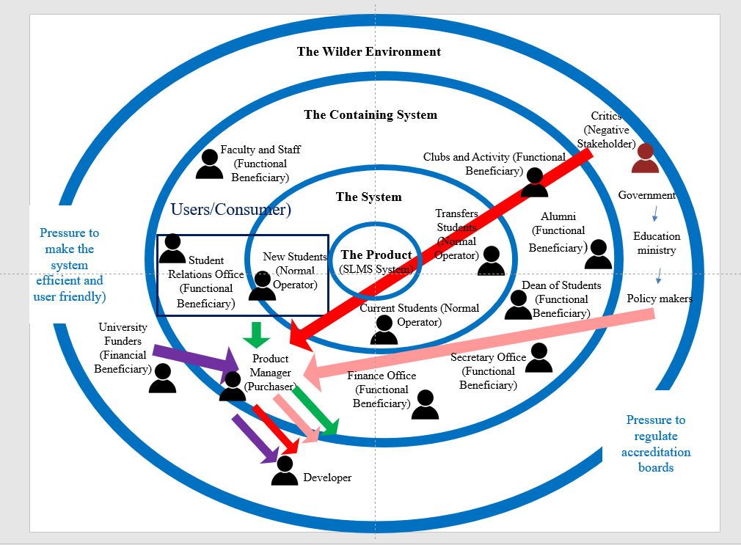

**2.3 Assumptions**

* User Authentication:
* It is assumed that staff members will log in to the SLMS using their university-issued email credentials, ensuring secure access and identity verification.
* Integration and Database:
* It is assumed that the SLMS interface and database are seamlessly integrated into the existing infrastructure of the university, facilitating consistent data flow and accessibility.
* Eligibility and Admission Process:
* It is assumed that all applicants using the SLMS are eligible to apply for the university, and the admission process is contingent on the accuracy of their application information and payment of relevant fees.
* System Security:
* It is assumed that the SLMS will be accessible and used exclusively by authorized personnel. The system will incorporate robust security measures, including user authentication and authorization, to safeguard sensitive student data.
* Scalability and Data Handling:
* It is assumed that the SLMS is designed to handle a large volume of data related to student applications and registrations. The system is expected to be scalable, adapting to the university's evolving needs without compromising performance.
  1. **Constraints**
* Users are expected to run the software on the well-known platforms Windows or Mac. Because of the complexity of the solution the device should have at least average computation power.
* The users should make sure to have reliable internet connection in order for the software to work.
* The intended audience (students, proffesors&staff, student relations office, finance office, secretary office, dean of students) are expected to be at least semi proficient in the English language to understand the utilities provided.
* The audience should know how to use the application.
* The back-end structure should be ready to respond to all requests at any time which might be highly concurrent peaking at university operating hours.
  1. **Dependencies**

|  |  |
| --- | --- |
| **Stakeholder** | **Dependencies** |
| Current Students | * Interaction with Faculty and Staff for academic guidance, course registration, and grading. * Potential collaboration with Clubs and Activities for extracurricular involvement and community engagement. * Possible interaction with Transfer Students for academic and social integration. * Potential engagement with Alumni for networking and mentorship opportunities. |
| Transfer Students | * Interaction with Faculty and Staff for credit transfer evaluation, academic advising, and course registration. * Potential collaboration with Clubs and Activities for extracurricular involvement and social integration. * Interaction with New Students for peer support and orientation to the university environment. * Possible engagement with Alumni for networking and support during the transition process. |
| New Students | * Interaction with Faculty and Staff for admission processes, academic advising, and course enrollment. * Potential collaboration with Clubs and Activities for exploring campus involvement opportunities. * Interaction with Current Students for peer support, orientation activities, and integration into the university community. * Possible engagement with Transfer Students for information exchange and support during the transition process. |
| Student Relations Office | * Collaboration with Current Students for processing inquiries, applications, and providing student support services. * Interaction with Faculty and Staff for coordinating student-related activities, academic advising, and resolving student issues. * Potential collaboration with Clubs and Activities for organizing student events, activities, and initiatives. * Collaboration with Transfer Students and New Students for orientation programs, support services, and integration into the university community. * Interaction with Alumni for alumni engagement programs, networking opportunities, and alumni relations. |
| Finance Office | * Interaction with Current Students for tuition payments, financial aid processing, and student account management. * Collaboration with Faculty and Staff for budget planning, grant management, and financial reporting related to academic programs and research projects. * Interaction with Clubs and Activities for budget allocations, financial oversight, and funding requests for student organizations. * Collaboration with Student Relations Office for financial transactions related to student admissions, registrations, and support services. |
| Secretary Office | * Interaction with Current Students, Transfer Students, and New Students for administrative support services, document processing, and record-keeping related to student enrollment, registration, and academic records. * Collaboration with Faculty and Staff for administrative tasks, scheduling, and coordination of academic activities, meetings, and events. * Interaction with Student Relations Office for coordination of student-related administrative processes, communication, and documentation. * Collaboration with Finance Office for administrative tasks related to budget management, procurement, and financial transactions. * Interaction with Alumni for administrative support services related to alumni relations, events, and communication. |
| Dean of Students/Administration | * Interaction with Current Students, Transfer Students, and New Students for academic advising, student support services, and resolution of student issues and concerns. * Collaboration with Faculty and Staff for academic program management, curriculum development, and student-related policies and procedures. * Interaction with Student Relations Office for coordination of student services, programs, and initiatives aimed at enhancing the student experience. * Collaboration with Finance Office for budget planning, resource allocation, and financial oversight of student-related activities and services. * Interaction with Alumni for alumni engagement initiatives, networking opportunities, and support for student development programs. |
| Alumni | * Interaction with Current Students for mentorship, career guidance, and networking opportunities aimed at supporting student success and professional development. * Collaboration with Student Relations Office for alumni engagement programs, events, and communication initiatives aimed at fostering connections between alumni and the university. * Interaction with Faculty and Staff for involvement in alumni-related academic and research initiatives, guest lectures, and industry partnerships. * Collaboration with Finance Office for financial contributions, donations, and fundraising efforts aimed at supporting university programs, scholarships, and facilities. * Interaction with Secretary Office for administrative support services, alumni records, and documentation related to alumni relations and activities. |
| Clubs and Activities | * Interaction with Current Students for membership recruitment, event participation, and leadership development opportunities within student organizations and clubs. * Collaboration with Student Relations Office for event planning, promotion, and coordination of club activities and initiatives. * Interaction with Faculty and Staff for faculty advisors, academic support, and collaboration on club-sponsored events, projects, and competitions. * Collaboration with Finance Office for budget allocations, funding requests, and financial oversight of club activities, events, and expenditures. * Interaction with Alumni for networking events, alumni mentorship, and sponsorship opportunities supporting club activities and initiatives. |
| Faculty and Staff | * Interaction with Current Students for teaching, academic advising, research supervision, and mentorship aimed at supporting student learning and development. * Collaboration with Student Relations Office for coordination of student services, academic support programs, and resolution of student issues and concerns. * Interaction with Clubs and Activities for involvement in extracurricular activities, faculty advisor roles, and collaboration on student-led initiatives and projects. * Collaboration with Finance Office for budget planning, grant management, and financial reporting related to academic programs, research projects, and departmental activities. * Interaction with Alumni for alumni engagement initiatives, guest lectures, industry partnerships, and networking opportunities supporting faculty research, teaching, and professional development. |

3. Requirements

**3.1 Functional Requirements**

The requirement numbering has a scheme – SLMS## (SLMS for Student Lifecycle Management System):

|  |  |  |  |  |
| --- | --- | --- | --- | --- |
| **Req#** | **Requirement** | **Comments** | **Priority** | **SLMS**  **Reviewed/**  **Approved** |
| SLMS_1 | The system must be supported by a web application. | * This is the main platform for using the software. | High | Joana Sulçe  Xhorxhina Meta  Dea Meçaj |
| SLMS_2 | User Authentication and Authorization | * Develop a view with different functionalities for the students * Develop a view with different functionalities for the SRO (admin) * Develop a view for the FO * Develop a view for the SO * Develop a view for the professors &staff, * Develop a view for dean of students(administration) * Develop a view for the administrative staff and the club organizers * Develop a view for the students portal. | High | Joana Sulçe  Xhorxhina Meta  Dea Meçaj |
| SLMS_3 | Design intuitive and user-friendly online forms for new student applications. | * Include fields for personal details, academic history, program preferences, and supporting documents (e.g., transcripts, letters of recommendation) * Enable applicants to save and resume incomplete applications. * Enhance the applicant experience by simplifying the application process and reducing manual paperwork. | High | Joana Sulçe  Xhorxhina Meta  Dea Meçaj |
| SLMS_4 | Application Review and Processing | * Develop a dashboard for admissions staff to view and manage incoming applications. Include filters, sorting options, and search functionality for efficient application review. * Enable staff to update application statuses, add comments, and communicate with applicants. | High | Joana Sulçe  Xhorxhina Meta  Dea Meçaj |
| SLMS_5 | Financial Transaction Tracking | * Maintain detailed records of transactions, including dates, amounts, payment methods, and status. | Medium | Joana Sulçe  Xhorxhina Meta  Dea Meçaj |
| SLMS_6 | Communication and Notification | * Implement messaging features for sending announcements, reminders, and notifications to students, faculty, and staff. * Improve communication effectiveness, increase user engagement, and keep stakeholders informed about important events and deadlines. | Medium | Joana Sulçe  Xhorxhina Meta  Dea Meçaj |
| SLMS_7 | Extracurricular Activities Management | * Develop tools for clubs and activities to create and manage profiles, events, meetings, and resources. * Enable students to search, join, and participate in clubs based on interests, goals, and availability. * Implement features for club leaders to track membership, attendance, and participation metrics. | Medium | Joana Sulçe  Xhorxhina Meta  Dea Meçaj |
| SLMS_8 | Alumni Tracking and Engagement | * Build a comprehensive database for storing alumni contact information, employment history, achievements, and affiliations. * Provide alumni with self-service tools to update their profiles, submit class notes, and connect with other alumni. * Strengthen alumni relations, leverage alumni expertise and resources, and cultivate lifelong connections between alumni and the university. | Medium | Joana Sulçe  Xhorxhina Meta  Dea Meçaj |
| SLMS_9 | Reporting and Analytics | * Develop a reporting dashboard with customizable reports, dashboards, and data visualization tools. * Incorporate data analytics capabilities for predictive modeling, trend analysis, and decision support. | Medium | Joana Sulçe  Xhorxhina Meta  Dea Meçaj |

**3.2 Non-Functional Requirements**

**3.2.1 Usability**

**3.2.2.1 Learnability:**

* The application is easy to use hence no specific training will be needed for the users.
* The application will know the specific users that are allowed to use the application (by the username), so it will not allow random users to login and use the application.

**3.2.2 Performance Requirements**

* The software will be based on web and has to be run from a web server.
* The software should support the SRO, SO, FO , Proffesors&Staff, dean of students, administrative staff and student that have access to the system.
* The application’s time of execution will depend on the user’s internet connection strength.
* The performance of the application will depend on the number of active user accessing the website

**3.2.3 Capacity**

* Every user will use the same database. If multiple requests are made to the server, the request will form a query.
* The application will be stored in a web server.
* The database will not be very large and complex.

**4. Analysis Model**

**4.1 User Scenarios**

|  |  |  |
| --- | --- | --- |
| **Number** | **User Story Name** | **Description** |
| 1 | Successful Login | * User logs in successfully by entering his email and password |
| 2 | Login failed | * User fails to login by using his email and password |
| 3 | Password forgotten | * User forgets his password, changes it by using a code received to his email account |
| 4 | Language chosen | * User changes the language from English to Albania or the other way around |
| 5 | New student applies to the university application form | * Student goes to the university page and fills out the application form |
| 6 | SRO chooses to view the pending list | * SRO logs in with their account and chooses to view the pending list that the student have applied from the application form |
| 7 | SRO chooses to edit the pending list | * SRO logs in with their account and chooses to edit the pending list where they can make comments about a student or accept or reject their application |
| 8 | SRO chooses to view the transactions list | * SRO logs in with their account and chooses to view the transactions list of students where they have made their payment |
| 9 | SRO chooses to view the registered list | * SRO logs in with their account and chooses to view the registered list of students |
| 10 | FO chooses to view the pending list | * FO logs in with their account and chooses to view the pending list that the student have applied from the application form |
| 11 | FO chooses to view the transactions list | * FO logs in with their account and chooses to view the transactions list of students where they have made their payment |
| 12 | FO chooses to edit the transactions list | * FO logs in with their account and chooses to edit the transactions list of students where they put if the student has made the transactions or not and the total sum and comment for every student |
| 13 | FO chooses to view the registered list | * FO logs in with their account and chooses to view the registered list of students |
| 14 | SO chooses to view the pending list | * SO logs in with their account and chooses to view the pending list that the student have applied from the application form |
| 15 | SO chooses to view the transactions list | * SO logs in with their account and chooses to view the transactions list of students where they have made their payment |
| 16 | SO chooses to view the registered list | * SO logs in with their account and chooses to view the registered list of students |
| 17 | SO chooses to edit the registered list | * SO logs in with their account and chooses to edit the list where they chooses to accept or reject the student |
| 18 | Proffesors & Staff chooses to view the pending list | * Proffesors & Staff logs in with their account and chooses to view the pending list that the student have applied from the application form |
| 19 | Proffesors & Staff chooses to view the transactions list | * Proffesors & Staff logs in with their account and chooses to view the transactions list of students where they have made their payment |
| 20 | Proffesors & Staff chooses to view the registered list | * Proffesors & Staff logs in with their account and chooses to view the registered list of students |
| 21 | Create Student Activities | * An administrative staff member creates new student activities, events, and clubs within the SLMS system, specifying details such as name, description, date, time, location, and relevant categories, to facilitate student engagement and participation. |
| 22 | Manage Student Activities | * Dean of Students manages existing student activities, events, and clubs within the SLMS system, edit details, update schedules, assign organizers, and track attendance to ensure successful execution and coordination. |
| 23 | Promote Student Activities | * An administrative staff member, promotes student activities, events, and clubs within the university community through the SLMS system, by creating announcements, sending notifications, and publishing information on the student portal, to increase awareness and participation. |
| 24 | Approve Student Activity Requests | * An administrative staff member, reviews and approves requests submitted by students to create new activities, events, or clubs, ensuring they align with university policies, guidelines, and objectives, to maintain quality and relevance in student programming. |
| 25 | Monitor Student Activity Participation | * Dean of Students monitors student participation and engagement in various activities, events, and clubs through the SLMS system, by tracking attendance, collecting feedback, and analyzing participation data, to assess the impact and effectiveness of student programming. |
| 26 | Provide Support to Club Organizers | * Dean of Students provides support and guidance to club organizers through the SLMS system, by offering resources, answering questions, and facilitating communication, to empower them in successfully managing their clubs and activities. |
| 27 | Evaluate Activity Impact | * An administrative staff member evaluates the impact and effectiveness of student activities, events, and clubs within the SLMS system, by collecting feedback, analyzing participation trends, and assessing outcomes, to inform future planning and decision-making. |
| 28 | Access Personal Information | * A student has access to view personal information stored in the SLMS system, including contact details, academic records, and enrollment status, to stay informed about their educational journey. |
| 29 | Update Personal Details | * A student updates my personal details (such as address, phone number, or emergency contacts) through the student portal, ensuring that their information is accurate and up-to-date for communication and administrative purposes. |
| 30 | Explore Extracurricular Activities | * A student explores and discovers extracurricular activities, clubs, and events available on campus through the student portal, including descriptions, schedules, and contact information, to enhance their college experience and get involved in campus life. |
| 31 | Receive Notifications and Announcements | * A student receives notifications and announcements through the student portal regarding important deadlines, events, campus news, academic updates, and other relevant information, to stay informed and engaged with the university community. |

**4.2 User Scenarios Extended**

|  |  |  |
| --- | --- | --- |
| **User Scenario Number** | **User Scenario Name** | **Description** |
| 1 | Successful Login | * The user is asked to enter the username * The user is asked to enter the password * The user presses the “Login” button * If the credentials of the users match in the database, user is authorized to be redirected. * The user logs in and is redirected to the main page of the application |
| 2 | Login Failed | * The user is asked to enter the username * The user is asked to enter the password * The user presses the “Login “ button * The user credentials don’t match with any on the database * An error message is displayed to the user * The user tries to enter his credentials again |
| 3 | Password forgotten | * The user forgets the password and clicks on the link “Forgot Password?”. * The user is redirected to another page where he is asked to enter an email address so a code to reset the password is going to be sent. * The user presses the “Send” button. * The user is redirected to another page where he is asked to enter the code that was received in his email address. * The user presses the “Verify” button. * The user is redirected to another page where he is asked to enter the new password twice. * The user presses the “Reset Password” button. * The user is redirected to the login page. * The user enters his email address and the new password. * The user presses the “Login” button. * The user is redirected to the main page of the application. |
| 4 | Language choosen | * The user is logged in the system. * The user’s main page will be the notification page. * The user clicks on the Settings menu. * The user clicks on the Language drop down menu. * English and Albanian appears. * The user chooses the language they want. |
| 5 | New Student Applies to the University Application Form | * The student is directed to the university's admission portal or application page. * On the application page, the student carefully fills out the required fields in the application form. * The application form typically includes fields such as personal information (name, date of birth, contact details), academic history (previous schools attended, grades, standardized test scores). * Once all required information is entered, the student reviews the entire application form to check for any errors or missing details. * After ensuring the accuracy of the information provided, the student submits the completed application form by clicking the designated button (e.g., "Submit" or "Apply Now"). * Upon submission, the application form is sent to the university's Admission System for review and processing. |
| 6 | SRO chooses to view the pending list | * The Student Relations Officer (SRO) accesses the university's Student Lifecycle Management System (SLMS) through their authorized account by entering their username and password on the login page. * Upon successful authentication, the SRO is directed to the main dashboard of the SLMS, where they have access to various administrative functionalities. * In the dashboard, the SRO locates and selects the option specifically designated for viewing pending applications or the pending list. This option may be prominently displayed as a clickable button or link labeled "View Pending List" or similar. * After clicking the "View Pending List" button, the system retrieves and displays a comprehensive list of pending applications submitted by prospective students. * Each entry in the pending list presents essential information about the applicant, including but not limited to: * Name: The first name of the student who submitted the application. * Surname: The last name of the student who submitted the application. * Program: The academic program or course to which the student has applied for admission. * Application Reference Number: A unique identifier assigned to each application for tracking purposes. * Status: The current status of the application (e.g., pending review, awaiting documents, under evaluation). * To view additional details or specific sections of an application, the SRO may click on the respective entry within the pending list. * The SRO concludes the session, having successfully viewed the pending list and performed necessary administrative tasks within the SLMS. |
| 7 | SRO chooses to edit the pending list | * The Student Relations Officer (SRO) accesses the university's Student Lifecycle Management System (SLMS) through their authorized account by providing their username and password on the login page. * Upon successful authentication, the SRO is directed to the main dashboard of the SLMS, which provides access to various administrative functionalities and options. * In the dashboard, the SRO navigates to the section or module specifically designated for managing pending applications or the pending list. * The SRO selects the option to edit the pending list, which allows them to review and modify details related to pending applications submitted by prospective students. * Based on their evaluation, the SRO may choose to take one of the following actions for each application: * Add Comments: If additional information or clarification is needed from the applicant, the SRO can input comments in the designated text field to communicate with the applicant or provide feedback. * Accept Application: If the application meets all requirements and criteria for admission, the SRO selects the "Accept" button to approve the application and proceed with the enrollment process. * Reject Application: If the application lacks necessary documentation, does not meet minimum academic standards, or for any other valid reason, the SRO selects the "Reject" button to decline the application. * Hold Application: In cases where further review or clarification is required before making a final decision, the SRO may choose to put the application on hold by selecting the appropriate option. * After making necessary edits or decisions for each application in the pending list, the SRO saves the changes by clicking on a designated "Save" or "Update" button provided by the SLMS. * SRO ensures data security and confidentiality by logging out of their account from the SLMS, preventing unauthorized access to sensitive student information. |
| 8 | SRO chooses to view the transactions list | * The Student Relations Officer (SRO) accesses the university's Student Lifecycle Management System (SLMS) using their authorized account credentials by navigating to the login page and entering their username and password. * Upon successful authentication, the SRO is redirected to the main dashboard or landing page of the SLMS, which provides access to various administrative functionalities and options. * In the dashboard, the SRO locates and selects the option specifically designated for viewing transaction records or the transactions list. * After selecting the "View Transactions List" option, the SLMS retrieves and presents a comprehensive list of transactions made by students, organized in a clear and easily navigable format. * The SRO concludes the session, having successfully viewed transaction records and performed necessary administrative tasks within the SLMS to manage student transactions effectively. |
| 9 | SRO chooses to view the registered list | * The Student Relations Officer (SRO) accesses the university's Student Lifecycle Management System (SLMS) using their authorized account credentials by navigating to the login page and entering their username and password. * Upon successful authentication, the SRO is directed to the main dashboard or landing page of the SLMS, which provides access to various administrative functionalities and options. * In the dashboard, the SRO navigates to the section or module specifically designated for managing student registration or viewing the registered list. * After selecting the "View Registered List" option, the SLMS retrieves and presents a comprehensive list of students who are currently registered for courses or enrolled in academic programs at the university. * After completing the necessary tasks related to viewing the registered list, the SRO ensures data security and confidentiality by logging out of their account from the SLMS. |
| 10 | FO chooses to view the pending list | * The Finance Office (FO) staff member accesses the university's Student Lifecycle Management System (SLMS) using their authorized account credentials by navigating to the login page and entering their username and password. * Upon successful authentication, the FO staff member is directed to the main dashboard or landing page of the SLMS, which provides access to various administrative functionalities and options. * After selecting the option to view the pending list, the SLMS retrieves and presents a comprehensive list of pending applications submitted by prospective students. * After completing the necessary tasks related to viewing the pending list, the FO staff member ensures data security and confidentiality by logging out of their account from the SLMS. |
| 11 | FO chooses to view the transactions list | * The Finance Office (FO) staff member accesses the university's Student Lifecycle Management System (SLMS) using their authorized account credentials by navigating to the login page and entering their username and password. * Upon successful authentication, the FO staff member is directed to the main dashboard or landing page of the SLMS, which provides access to various administrative functionalities and options. * Upon successful authentication, the FO staff member is directed to the main dashboard or landing page of the SLMS, which provides access to various administrative functionalities and options. * After completing the necessary tasks related to viewing the transactions list, the FO staff member ensures data security and confidentiality by logging out of their account from the SLMS. |
| 12 | FO chooses to edit the transactions list | * The Finance Office (FO) staff member accesses the university's Student Lifecycle Management System (SLMS) using their authorized account credentials by navigating to the login page and entering their username and password. * Upon successful authentication, the FO staff member is directed to the main dashboard or landing page of the SLMS, which provides access to various administrative functionalities and options. * After selecting the option to edit the transactions list, the SLMS retrieves and presents a comprehensive list of transactions made by students. * Each entry in the transactions list includes essential information about the transaction, such as: * Student Name: The full name of the student who initiated the transaction. * Student ID: A unique identifier assigned to each student for tracking and administrative purposes. * Transaction ID: A unique identifier assigned to each transaction for tracking and administrative purposes. * Date of Transaction: The date and time when the transaction was processed or completed. * Status: Indicates the current status of the transaction (e.g., pending, completed, refunded). * Comment: A field where the FO staff member can input comments or notes related to the transaction. * The FO staff member carefully reviews the transactions list, scanning through the entries to identify specific transactions or details of interest. * The FO staff member may update transaction information by performing the following actions: * Editing Transaction Details: The FO staff member can modify transaction amounts, payment statuses, or other relevant details as needed. * Adding Comments: If additional information or clarification is required for a transaction, the FO staff member can input comments in the designated comment field. * Verifying Transactions: The FO staff member can indicate whether the transaction has been verified or not by checking the appropriate checkbox or option. * Upon completing the necessary edits or updates to the transactions list, the FO staff member saves the changes by clicking on a designated "Save" or "Update" button provided by the SLMS. * After saving the changes, the FO staff member ensures data security and confidentiality by logging out of their account from the SLMS. |
| 13 | FO chooses to view the registered list | * The Finance Office (FO) staff member accesses the university's Student Lifecycle Management System (SLMS) using their authorized account credentials by navigating to the login page and entering their username and password. * Upon successful authentication, the FO staff member is directed to the main dashboard or landing page of the SLMS, which provides access to various administrative functionalities and options. * In the dashboard, the FO navigates to the section or module specifically designated for managing student registration or viewing the registered list. * After selecting the "View Registered List" option, the SLMS retrieves and presents a comprehensive list of students who are currently registered for courses or enrolled in academic programs at the university. * After completing the necessary tasks related to viewing the registered list, the FO ensures data security and confidentiality by logging out of their account from the SLMS. |
| 14 | SO chooses to view the pending list | * The Secretary Office (SO) staff member accesses the university's Student Lifecycle Management System (SLMS) using their authorized account credentials by navigating to the login page and entering their username and password. * Upon successful authentication, the SO staff member is directed to the main dashboard or landing page of the SLMS, which provides access to various administrative functionalities and options. * After selecting the option to view the pending list, the SLMS retrieves and presents a comprehensive list of pending applications submitted by prospective students. * After completing the necessary tasks related to viewing the pending list, the SO staff member ensures data security and confidentiality by logging out of their account from the SLMS. |
| 15 | SO chooses to view the transactions list | * The Student Relations Officer (SO) accesses the university's Student Lifecycle Management System (SLMS) using their authorized account credentials by navigating to the login page and entering their username and password. * Upon successful authentication, the SO is redirected to the main dashboard or landing page of the SLMS, which provides access to various administrative functionalities and options. * In the dashboard, the SO locates and selects the option specifically designated for viewing transaction records or the transactions list. * After selecting the "View Transactions List" option, the SLMS retrieves and presents a comprehensive list of transactions made by students, organized in a clear and easily navigable format. * The SO concludes the session, having successfully viewed transaction records and performed necessary administrative tasks within the SLMS to manage student transactions effectively. |
| 16 | SO chooses to view the registered list | * The Secretary Office (SO) staff member accesses the university's Student Lifecycle Management System (SLMS) using their authorized account credentials by navigating to the login page and entering their username and password. * Upon successful authentication, the SO staff member is directed to the main dashboard or landing page of the SLMS, which provides access to various administrative functionalities and options. * In the dashboard, the SO navigates to the section or module specifically designated for managing student registration or viewing the registered list. * After selecting the "View Registered List" option, the SLMS retrieves and presents a comprehensive list of students who are currently registered for courses or enrolled in academic programs at the university. * After completing the necessary tasks related to viewing the registered list, the SO ensures data security and confidentiality by logging out of their account from the SLMS. |
| 17 | SO chooses to edit the registered list | * The Student Relations Office (SO) staff member accesses the university's Student Lifecycle Management System (SLMS) using their authorized account credentials by navigating to the login page and entering their username and password. * Upon successful authentication, the SO staff member is directed to the main dashboard or landing page of the SLMS, which provides access to various administrative functionalities and options. * After selecting the option to edit the registered list, the SLMS retrieves and presents a comprehensive list of students who are currently registered for courses or enrolled in academic programs at the university. * Each entry in the registered list includes essential information about the student, such as: * Student Name: The full name of the student. * Student ID: A unique identifier assigned to each student for tracking and administrative purposes. * Program/Course: Specifies the academic program or course in which the student is enrolled. * Registration Status: Indicates whether the student's registration is active or pending. * Contact Information: Includes the student's contact details, such as email address and phone number. * For each student entry in the list, the SO staff member has the option to take one of the following actions: * Accept Student: If the student's registration is in order and meets all requirements, the SO staff member can choose to accept the student's registration by updating the registration status accordingly. * Reject Student: If there are issues with the student's registration or if the student does not meet eligibility criteria, the SO staff member can choose to reject the student's registration by updating the registration status accordingly. * The SO staff member may also input additional comments or notes regarding the decision to accept or reject the student, providing context or justification for the action taken. * Upon completing the necessary edits to the registered list, including accepting or rejecting students and adding comments, the SO staff member saves the changes by clicking on a designated "Save" or "Update" button provided by the SLMS. * After saving the changes, the SO staff member ensures data security and confidentiality by logging out of their account from the SLMS. |
| 18 | Proffesors & Staff chooses to view the pending list | * The Proffesors& Staff member accesses the university's Student Lifecycle Management System (SLMS) using their authorized account credentials by navigating to the login page and entering their username and password. * Upon successful authentication, the Proffesors& Staff member is directed to the main dashboard or landing page of the SLMS, which provides access to various administrative functionalities and options. * After selecting the option to view the pending list, the SLMS retrieves and presents a comprehensive list of pending applications submitted by prospective students. * After completing the necessary tasks related to viewing the pending list, the Proffesors& Staff member ensures data security and confidentiality by logging out of their account from the SLMS. |
| 19 | Proffesors & Staff chooses to view the transactions list | * The Proffesors& Staff accesses the university's Student Lifecycle Management System (SLMS) using their authorized account credentials by navigating to the login page and entering their username and password. * Upon successful authentication, the Proffesors& Staff is redirected to the main dashboard or landing page of the SLMS, which provides access to various administrative functionalities and options. * In the dashboard, the Proffesors& Staff locates and selects the option specifically designated for viewing transaction records or the transactions list. * After selecting the "View Transactions List" option, the SLMS retrieves and presents a comprehensive list of transactions made by students, organized in a clear and easily navigable format. * The Proffesors& Staff concludes the session, having successfully viewed transaction records and performed necessary administrative tasks within the SLMS to manage student transactions effectively. |
| 20 | Proffesors & Staff chooses to view the registered list | * The Proffesors& Staff member accesses the university's Student Lifecycle Management System (SLMS) using their authorized account credentials by navigating to the login page and entering their username and password. * Upon successful authentication, the Proffesors& Staff member is directed to the main dashboard or landing page of the SLMS, which provides access to various administrative functionalities and options. * In the dashboard, the Proffesors& Staff navigates to the section or module specifically designated for managing student registration or viewing the registered list. * After selecting the "View Registered List" option, the SLMS retrieves and presents a comprehensive list of students who are currently registered for courses or enrolled in academic programs at the university. * After completing the necessary tasks related to viewing the registered list, the Proffesors& Staff ensures data security and confidentiality by logging out of their account from the SLMS. |
| 21 | Create Student Activities | * An administrative staff member accesses the university's Student Lifecycle Management System (SLMS) using their authorized account credentials by navigating to the login page and entering their username and password. * Upon successful authentication, the staff member is directed to the main dashboard or landing page of the SLMS, which provides access to various administrative functionalities and options. * After selecting the option to create new activities, events, or clubs, the SLMS presents a form or interface for entering details about the activity. * The staff member fills out the required fields in the form, providing information such as: * Activity Name: The name or title of the activity, event, or club. * Description: A brief overview or description of the activity, event, or club, highlighting its purpose, goals, and intended audience. * Date and Time: The date and time when the activity or event will take place. * Location: The venue or location where the activity or event will be held. * Categories: Relevant categories or tags to classify the activity, event, or club (e.g., academic, social, cultural, sports). * Additional Details: Any additional information or requirements for participants, such as registration procedures, fees, or prerequisites. * Optionally, the SLMS may provide advanced options for specifying event settings, such as capacity limits, registration deadlines, or recurring schedules for recurring events. * Upon creation, the SLMS stores the information and updates the database to include the newly added activity, event, or club in the system. * The staff member may review the created activity, event, or club to ensure that all details are accurate and complete. * After completing the creation process and any associated tasks, the staff member ensures data security and confidentiality by logging out of their account from the SLMS. |
| 22 | Manage Student Activities | * The Dean of Students accesses the university's Student Lifecycle Management System (SLMS) using their authorized account credentials by navigating to the login page and entering their username and password. * Upon successful authentication, the Dean of Students is directed to the main dashboard or landing page of the SLMS, which provides access to various administrative functionalities and options. * In the dashboard, the Dean of Students navigates to the section or module specifically designated for managing student activities, events, and clubs. * The Dean of Students views the list of existing student activities, events, and clubs displayed within the SLMS. * To manage an existing activity, event, or club, the Dean of Students selects the desired item from the list or searches for it using filters or search functionality. * After selecting the activity, event, or club to manage, the SLMS presents options for editing details, updating schedules, assigning organizers, and tracking attendance. * Editing Details: * The Dean of Students can modify various details of the activity, event, or club, such as the name, description, date, time, location, and categories. * Any changes made are saved within the SLMS to update the information stored in the system. * Updating Schedules: * If there are changes to the schedule of an activity or event, the Dean of Students can update the date, time, and venue accordingly. * The SLMS reflects the updated schedule, ensuring accuracy in the information provided to participants. * Assigning Organizers: * The Dean of Students can assign organizers or responsible individuals to manage specific activities, events, or clubs. * Organizers may be selected from a list of staff members or student leaders registered within the SLMS. * After making any necessary changes and updates, the Dean of Students ensures that the information is accurate and complete before saving the modifications within the SLMS. * Upon completion of management tasks, the Dean of Students ensures data security and confidentiality by logging out of their account from the SLMS. |
| 23 | Promote Student Activities | * An administrative staff member accesses the university's Student Lifecycle Management System (SLMS) using their authorized account credentials by navigating to the login page and entering their username and password. * Upon successful authentication, the staff member is directed to the main dashboard or landing page of the SLMS, which provides access to various administrative functionalities and options. * In the dashboard, the staff member navigates to the section or module specifically designated for promoting student activities, events, and clubs. * The staff member selects the option to create announcements, send notifications, or publish information related to student activities within the university community. * Creating Announcements: * The staff member composes announcements with details about upcoming activities, events, or clubs, including their names, descriptions, dates, times, locations, and any other relevant information. * Announcements may include engaging content, visuals, or multimedia elements to attract attention and generate interest among students. * Sending Notifications: * The staff member utilizes notification features within the SLMS to send messages directly to students, informing them about upcoming activities, events, or clubs. * Notifications may be sent via email, SMS, or through the SLMS's internal messaging system, depending on the preferences and contact information of the recipients. * Publishing Information on the Student Portal: * The staff member leverages the student portal within the SLMS to publish information about student activities, events, and clubs, making it easily accessible to the university community. * Information published on the student portal may include event calendars, club directories, registration forms, and other resources to facilitate student engagement and participation. * After creating announcements, sending notifications, and publishing information, the staff member ensures that the content is accurate, relevant, and engaging to maximize its impact on increasing awareness and participation. * Upon completion of promotional activities, the staff member ensures data security and confidentiality by logging out of their account from the SLMS. |
| 24 | Approve Student Activity Requests | * An administrative staff member accesses the university's Student Lifecycle Management System (SLMS) using their authorized account credentials by navigating to the login page and entering their username and password. * Upon successful authentication, the staff member is directed to the main dashboard or landing page of the SLMS, which provides access to various administrative functionalities and options * In the dashboard, the staff member navigates to the section or module specifically designated for managing student activity requests. * The staff member views a list of pending activity requests submitted by students, which includes details such as the proposed activity name, description, date, time, location, and relevant categories. * The staff member selects a request from the list to review and evaluate its alignment with university policies, guidelines, and objectives. * Reviewing Activity Request: * The staff member carefully reads through the details provided in the activity request to assess its feasibility, relevance, and compliance with university policies. * Factors considered may include the proposed activity's purpose, potential impact on the university community, logistical feasibility, and adherence to budgetary constraints. * Decision Making: * Based on their assessment, the staff member decides whether to approve or deny the activity request. * If the request meets all criteria and aligns with university policies, guidelines, and objectives, the staff member approves the activity request. * If the request does not meet the criteria or raises concerns regarding compliance or feasibility, the staff member may deny the activity request and provide feedback or guidance to the student. * Recording Decision: * The staff member updates the status of the activity request within the SLMS, indicating whether it has been approved or denied, along with any relevant comments or notes. * After completing the approval process, the staff member ensures data security and confidentiality by logging out of their account from the SLMS. |
| 25 | Monitor Student Activity Participation | * The Dean of Students accesses the university's Student Lifecycle Management System (SLMS) using their authorized account credentials by navigating to the login page and entering their username and password. * Upon successful authentication, the Dean of Students is directed to the main dashboard or landing page of the SLMS, which provides access to various administrative functionalities and options. * In the dashboard, the Dean of Students navigates to the section or module specifically designated for monitoring student activity participation. * The Dean of Students views a comprehensive overview of student activities, events, and clubs available within the SLMS, along with relevant participation data. * Tracking Attendance: * The Dean of Students accesses attendance records for various activities and events, tracking the number of students who have participated in each. * Attendance data may be recorded manually by organizers or through automated check-in systems integrated with the SLMS. * Collecting Feedback: * The Dean of Students reviews feedback collected from students regarding their experiences with different activities, events, and clubs. * Feedback may include surveys, evaluations, or comments submitted by students through the SLMS, providing insights into their satisfaction levels and suggestions for improvement. * Analyzing Participation Data: * The Dean of Students analyzes participation data to identify trends, patterns, and areas of interest among students. * They assess factors such as the popularity of specific activities, demographic trends in participation, and the overall level of engagement within the university community. |
|  |  | * Communicating Insights: * The Dean of Students communicates insights and findings derived from monitoring student activity participation to relevant stakeholders, such as student government, faculty advisors, and administrative departments. * Insights may be shared through reports, presentations, or meetings to facilitate informed decision-making and collaboration in enhancing student programming. * After completing the monitoring process and any associated tasks, the Dean of Students ensures data security and confidentiality by logging out of their account from the SLMS. |
| 26 | Provide Support to Club Organizers | * The Dean of Students accesses the university's Student Lifecycle Management System (SLMS) using their authorized account credentials by navigating to the login page and entering their username and password. * Upon successful authentication, the Dean of Students is directed to the main dashboard or landing page of the SLMS, which provides access to various administrative functionalities and options. * In the dashboard, the Dean of Students navigates to the section or module specifically designated for providing support to club organizers. * Viewing Club Organizer Requests: * The Dean of Students reviews requests and inquiries submitted by club organizers through the SLMS, seeking assistance or guidance. * Requests may include questions about club management, requests for resources or funding, or inquiries about university policies and procedures. * Answering Questions: * The Dean of Students responds promptly to inquiries and questions from club organizers, addressing concerns and providing clarification on matters related to club management, university policies, and SLMS functionalities. * Answers may be provided through direct messages within the SLMS, email communication, or scheduled meetings, depending on the complexity of the issue and the preferences of the club organizers. * After providing support to club organizers and addressing their inquiries, the Dean of Students ensures data security and confidentiality by logging out of their account from the SLMS. |
| 27 | Evaluate Activity Impact | * The Dean of Students accesses the university's Student Lifecycle Management System (SLMS) using their authorized account credentials by navigating to the login page and entering their username and password. * Upon successful authentication, the Dean of Students is directed to the main dashboard or landing page of the SLMS, which provides access to various administrative functionalities and options. * In the dashboard, the staff member navigates to the section or module specifically designated for evaluating the impact of student activities, events, and clubs. * Collecting Feedback: * The staff member collects feedback from participants and stakeholders involved in various activities, events, and clubs through surveys, evaluations, or feedback forms integrated into the SLMS. * Feedback may include opinions, suggestions, and ratings regarding the quality, relevance, and impact of the activities on the student experience. * Assessing Outcomes: * Based on feedback and participation data, the staff member assesses the outcomes and achievements of student activities, events, and clubs in meeting their objectives and goals. * They evaluate factors such as student satisfaction, learning outcomes, skill development, community impact, and alignment with university priorities and values. * After completing the evaluation process and any associated tasks, the staff member ensures data security and confidentiality by logging out of their account from the SLMS. |
| 28 | Access Personal Information | * A student accesses the university's Student Lifecycle Management System (SLMS) using their authorized account credentials by navigating to the login page and entering their username and password. * Upon successful authentication, the student is directed to their personalized dashboard or profile page within the SLMS, which provides access to various academic and administrative functionalities. * In the dashboard or profile page, the student navigates to the section specifically designated for accessing personal information. * Viewing Contact Details: * The student views their contact details stored in the SLMS, which may include their full name, email address, phone number, mailing address, and any other contact information provided to the university. * Contact details are displayed in a secure and easily accessible format for the student's reference. * Accessing Academic Records: * The student accesses their academic records stored in the SLMS, which may include information such as courses enrolled, grades obtained, academic standing, GPA (Grade Point Average), and transcripts. * Academic records are organized and presented in a clear and comprehensive manner, allowing the student to track their progress and performance throughout their educational journey. * Checking Enrollment Status: * The student checks their enrollment status within the SLMS, which indicates whether they are currently enrolled in courses, on leave, or withdrawn from the university. * Enrollment status provides the student with real-time information about their academic standing and eligibility to access university resources and services. * Reviewing Other Personal Information: * In addition to contact details, academic records, and enrollment status, the student may have access to other personal information stored in the SLMS, such as emergency contact information, financial aid status, and campus affiliations. * The SLMS ensures the privacy and security of personal information, adhering to data protection regulations and university policies. * After reviewing their personal information and any associated tasks, the student ensures data security and confidentiality by logging out of their account from the SLMS. |
| 29 | Update Personal Details | * A student accesses the university's Student Lifecycle Management System (SLMS) using their authorized account credentials by navigating to the login page and entering their username and password. * Upon successful authentication, the student is directed to their personalized dashboard or profile page within the SLMS, which provides access to various academic and administrative functionalities. * In the dashboard or profile page, the student navigates to the section specifically designated for updating personal details. * Editing Personal Information: * The student selects the option to edit personal details and is presented with a form or interface containing fields for different types of information, such as address, phone number, and emergency contacts. * Saving Changes: * Once satisfied with the updates, the student saves the changes within the SLMS. * The SLMS stores the revised personal details securely and updates the student's profile with the new information. * After updating their personal details and any associated tasks, the student ensures data security and confidentiality by logging out of their account from the SLMS. |
| 30 | Explore Extracurricular Activities | * A student accesses the university's Student Lifecycle Management System (SLMS) using their authorized account credentials by navigating to the login page and entering their username and password. * Upon successful authentication, the student is directed to their personalized dashboard or homepage within the SLMS, which provides access to various academic and administrative functionalities. * In the dashboard or homepage, the student navigates to the section specifically designated for exploring extracurricular activities. * Browsing Available Activities: * The student views a comprehensive list of extracurricular activities, clubs, and events available on campus, organized in categories or sections for easy navigation. * Activities may include academic clubs, sports teams, cultural organizations, volunteer groups, special interest clubs, and campus events. * Exploring Descriptions: * The student selects an activity or club from the list to explore further and is presented with a detailed description of the selected activity. * Descriptions provide information about the purpose, goals, mission, activities, and benefits of participating in the club or event. * Checking Schedules: * After reviewing the description, the student checks the schedule or calendar of events associated with the selected activity. * Schedules include information about upcoming meetings, practices, workshops, competitions, performances, and other relevant events. * After exploring extracurricular activities and any associated tasks, the student ensures data security and confidentiality by logging out of their account from the SLMS. |
| 31 | Receive Notifications and Announcements | * A student accesses the university's Student Lifecycle Management System (SLMS) using their authorized account credentials by navigating to the login page and entering their username and password. * Upon successful authentication, the student is directed to their personalized dashboard or homepage within the SLMS, which serves as the central hub for accessing academic and administrative information. * In the dashboard or homepage, the student navigates to the section specifically designated for receiving notifications and announcements. * Viewing Notifications: * The student views a list of notifications displayed in chronological order, highlighting important deadlines, events, campus news, academic updates, and other relevant information. * Notifications may include reminders about registration deadlines, upcoming exams, financial aid deadlines, campus closures, special events, guest lectures, club meetings, and other campus activities. * Receiving Alerts: * The SLMS sends alerts to the student's account or registered email address to notify them of new notifications and announcements as they are posted. * Alerts ensure that students stay informed in real-time about important updates and events within the university community. * After receiving notifications and announcements and any associated tasks, the student ensures data security and confidentiality by logging out of their account from the SLMS. |

**4.3 Use cases**

|  |  |
| --- | --- |
| **Name** | Successful Login |
| **Summary** | This use case describes the process of a user successfully logging into the application by providing valid credentials and being redirected to the main page upon authentication. |
| **Actor** | User (Student, Faculty, Staff, etc.) |
| **Description** | 1. User goes to application login page. 2. User inputs username and password. 3. User clicks "Login" button. 4. System verifies credentials with database. 5. If match found, user is authenticated. 6. Upon successful authentication, user gains application access. 7. User is directed to main dashboard for feature access. |
| **Precondition** | * The user must have a valid username and password registered in the system. * The application login page must be accessible. |
| **Alternative** | * If the entered username or password is incorrect, the system displays an error message prompting the user to retry or reset their credentials. |
| **Post Condition** | * The user successfully logs into the application and gains access to its features and functionalities. * The user is redirected to the main page/dashboard of the application. |

|  |  |
| --- | --- |
| **Name** | Login Failed |
| **Summary** | This use case outlines the scenario where a user attempts to log into the application with incorrect credentials, resulting in a failed login attempt and the display of an error message. |
| **Actor** | User (Student, Faculty, Staff, etc.) |
| **Description** | 1. User navigates to application login page. 2. System prompts user for username and password. 3. User inputs username and password. 4. User clicks "Login" button. 5. System verifies credentials with database. 6. If no match found, login attempt fails. 7. System shows error message for incorrect credentials. 8. User is prompted to retry. 9. User repeats steps 2-4 for credential re-entry. |
| **Precondition** | * The user must have attempted to log into the application with incorrect credentials. * The application login page must be accessible. |
| **Alternative** | * If the user repeatedly fails to log in after multiple attempts, the system may impose restrictions or security measures, such as temporarily locking the account or requiring additional authentication steps. |
| **Post Condition** | * The user's login attempt fails, and an error message is displayed. * The user is prompted to retry entering their credentials. |

|  |  |
| --- | --- |
| **Name** | Password Forgotten |
| **Summary** | This use case describes the process of a user resetting their forgotten password and successfully logging into the application with the new password. |
| **Actor** | User (Student, Faculty, Staff, etc.) |
| **Description** | 1. User goes to application login page. 2. User clicks "Forgot Password?" link. 3. User is directed to password reset page. 4. User inputs email address and clicks "Send". 5. System sends reset code to user's email. 6. User enters code on password reset page and clicks "Verify". 7. System validates code. 8. Upon successful verification, user sets new password. 9. User inputs new password twice and clicks "Reset Password". 10. System resets password and redirects to login page. 11. User inputs email and new password. 12. User clicks "Login" to submit. 13. System verifies credentials and grants access. 14. User lands on main dashboard of the application. |
| **Precondition** | * The user must have forgotten their password and initiated the password reset process. * The user must have access to their email account to receive the password reset code. |
| **Alternative** | * If the user does not receive the password reset code, they may request to resend the code or contact support for assistance. |
| **Post Condition** | * The user successfully resets their password and logs into the application with the new password. * The user gains access to the main page/dashboard of the application. |

|  |  |
| --- | --- |
| **Name** | Language Selection |
| **Summary** | This use case describes the process of a user selecting their preferred language within the system settings. |
| **Actor** | User (Student, Faculty, Staff, etc.) |
| **Description** | 1. User logs in, landing on the notification page. 2. User navigates to Settings menu. 3. User selects Language dropdown. 4. Dropdown displays available languages. 5. English and Albanian are options. 6. User clicks preferred language. 7. System updates language setting. 8. Application displays in chosen language. 9. User interacts with system in selected language. |
| **Precondition** | * The user must be logged into the system. * The user must have access to the Settings menu. * The system must support multiple languages, with English and Albanian being available options. |
| **Alternative** | * If the user's preferred language is not available in the dropdown menu, they may contact support or system administrators to request additional language options. |
| **Post Condition** | * The user successfully selects their preferred language within the system settings. * The user interface elements and text are displayed in the chosen language throughout the application. |

|  |  |
| --- | --- |
| **Name** | New Student Applies to the University Application Form |
| **Summary** | This use case describes the process of a new student applying to the university through the admission portal or application page. |
| **Actor** | Student |
| **Description** | 1. Student accesses university's admission portal. 2. Student fills out required fields in application form. 3. Student reviews completed form for accuracy. 4. Student submits application. 5. Application is sent to university's Admission System for review. |
| **Precondition** | * The student must have access to the university's admission portal or application page. * The student should have relevant personal and academic information available to fill out the application form. |
| **Alternative** | * If the student encounters technical issues or difficulties during the application process, they may contact the university's admission office for assistance or seek support through designated channels. |
| **Post Condition** | * The student successfully completes and submits the application form to the university for review and processing. * The university's Admission System receives the application and begins the review process to assess the student's eligibility for admission. |

|  |  |
| --- | --- |
| **Name** | SRO Views Pending List |
| **Summary** | This use case describes the process of the Student Relations Officer (SRO) accessing and reviewing the pending list of applications submitted by prospective students within the university's Student Lifecycle Management System (SLMS). |
| **Actor** | Student Relations Officer (SRO) |
| **Description** | 1. SRO logs into SLMS. 2. SRO navigates to view pending applications. 3. SRO selects "View Pending List" option. 4. SLMS shows comprehensive list of pending applications. 5. SRO can review individual applications by clicking entries. 6. SRO concludes session after reviewing pending list. |
| **Precondition** | * The SRO must have access to the university's SLMS with authorized account credentials. * There must be pending applications in the system for the SRO to view. |
| **Alternative** | * If the SRO encounters technical issues or difficulties accessing the pending list, they may seek assistance from the IT support team or contact system administrators for troubleshooting. |
| **Post Condition** | * The SRO successfully views the pending list and may proceed with further administrative actions as needed within the SLMS. |

|  |  |
| --- | --- |
| **Name** | SRO Edits Pending List |
| **Summary** | This use case describes the process of the Student Relations Officer (SRO) accessing and editing the pending list of applications submitted by prospective students within the university's Student Lifecycle Management System (SLMS). |
| **Actor** | Student Relations Officer (SRO) |
| **Description** | 1. SRO logs into SLMS using authorized credentials. 2. SRO upon successful authentication, is directed to main dashboard. 3. SRO navigates to section for managing pending applications. 4. SRO selects "Edit Pending List" option to review and modify details. 5. SRO for each application:    1. Adds comments if needed.    2. Accepts application meeting requirements.    3. Rejects application lacking documentation or not meeting standards.    4. Holds application pending further review. 6. SRO saves changes after editing each application. 7. SRO ensures data security by logging out of SLMS. |
| **Precondition** | * The SRO must have access to the university's SLMS with authorized account credentials. * There must be pending applications in the system for the SRO to edit. |
| **Alternative** | * If the SRO encounters technical issues or difficulties accessing the pending list, they may seek assistance from the IT support team or contact system administrators for troubleshooting. * In cases where additional information is required from the applicant, the SRO may communicate directly with the applicant via email or phone to gather the necessary details. |
| **Post Condition** | * The SRO successfully reviews and edits the pending list, making necessary decisions for each application. * Changes made by the SRO are saved in the SLMS, updating the status of pending applications accordingly. |

|  |  |
| --- | --- |
| **Name** | SRO Views Transactions List |
| **Summary** | This use case describes the process of the Student Relations Officer (SRO) accessing and viewing the transactions list of students within the university's Student Lifecycle Management System (SLMS). |
| **Actor** | Student Relations Officer (SRO) |
| **Description** | 1. SRO accesses SLMS login page. 2. SRO enters authorized credentials. 3. Upon successful login, SRO reaches main dashboard. 4. SRO selects "View Transactions List" option. 5. SLMS retrieves and displays student transactions. 6. Transactions list is organized for easy review. 7. SRO completes necessary administrative tasks. 8. SRO concludes session. |
| **Precondition** | * The Student Relations Officer (SRO) must have access to the university's Student Lifecycle Management System (SLMS) with authorized account credentials. * There must be transaction records available in the SLMS for the SRO to view. |
| **Alternative** | * If the SRO encounters technical issues or difficulties accessing the transactions list, they may seek assistance from the IT support team or contact system administrators for troubleshooting. * In cases where specific transaction details are required, the SRO may request additional information from the finance office or relevant administrative personnel. |
| **Post Condition** | * The SRO successfully views the transactions list of students within the SLMS |

|  |  |
| --- | --- |
| **Name** | SRO Views Registered List |
| **Summary** | This use case describes the process of the Student Relations Officer (SRO) accessing and viewing the registered list of students within the university's Student Lifecycle Management System (SLMS). |
| **Actor** | Student Relations Officer (SRO) |
| **Description** | 1. SRO accesses SLMS login page. 2. SRO enters username and password. 3. Upon successful login, SRO reaches main dashboard. 4. SRO navigates to student registration section. 5. SRO selects "View Registered List" option. 6. SLMS retrieves and displays list of registered students. 7. SRO completes necessary tasks. 8. SRO logs out for data security. |
| **Precondition** | * The Student Relations Officer (SRO) must have access to the university's Student Lifecycle Management System (SLMS) with authorized account credentials. * There must be registered students' records available in the SLMS for the SRO to view. |
| **Alternative** | * If the SRO encounters technical issues or difficulties accessing the registered list, they may seek assistance from the IT support team or contact system administrators for troubleshooting. * In cases where specific student information is required, the SRO may request additional details from the relevant administrative offices. |
| **Post Condition** | * The SRO successfully views the registered list of students within the SLMS. |

|  |  |
| --- | --- |
| **Name** | FO Views Pending List |
| **Summary** | This use case outlines the process of a Finance Office (FO) staff member accessing and viewing the pending list of applications submitted by prospective students within the university's Student Lifecycle Management System (SLMS). |
| **Actor** | Finance Office (FO) Staff Member |
| **Description** | 1. FO logs into SLMS. 2. FO navigates to view pending applications. 3. FO selects "View Pending List" option. 4. SLMS displays comprehensive list of pending applications. 5. FO reviews additional details by clicking on entries. 6. FO concludes session after reviewing pending list. |
| **Precondition** | * The Finance Office (FO) staff member must have access to the university's Student Lifecycle Management System (SLMS) with authorized account credentials. |
| **Alternative** | * If the FO staff member encounters technical difficulties accessing the pending list, they may seek assistance from the IT support team or contact system administrators for troubleshooting. |
| **Post Condition** | * The FO staff member successfully views the pending list of applications within the SLMS. |

|  |  |
| --- | --- |
| **Name** | FO Views Transactions List |
| **Summary** | This use case outlines the process of a Finance Office (FO) staff member accessing and viewing the transactions list of students within the university's Student Lifecycle Management System (SLMS). |
| **Actor** | Finance Office (FO) Staff Member |
| **Description** | 1. FO staff member logs into SLMS. 2. Directed to main dashboard upon successful authentication. 3. Selects "View Transactions List" option. 4. SLMS retrieves and presents transactions list. 5. List includes student names, transaction IDs, dates, amounts, and payment methods. 6. FO staff member reviews transactions for student payments and fees. 7. Logs out after completing tasks. |
| **Precondition** | * The Finance Office (FO) staff member must have access to the university's Student Lifecycle Management System (SLMS) with authorized account credentials. |
| **Alternative** | * If the FO staff member encounters technical difficulties accessing the transactions list, they may seek assistance from the IT support team or contact system administrators for troubleshooting. |
| **Post Condition** | * The FO staff member successfully views the transactions list of students within the SLMS. |

|  |  |
| --- | --- |
| **Name** | FO Edits Transactions List |
| **Summary** | This use case describes the process wherein a Finance Office (FO) staff member edits transaction records in the university's Student Lifecycle Management System (SLMS). |
| **Actor** | Finance Office (FO) staff member |
| **Description** | 1. FO staff member logs into SLMS. 2. Upon successful login, FO is directed to main dashboard. 3. FO selects option to edit transactions list. 4. SLMS displays comprehensive transactions list. 5. Each entry includes student name, ID, transaction details, date, status, and comments. 6. FO reviews transactions for specific details. 7. FO updates transaction info, adds comments, or verifies transactions. 8. After edits, FO saves changes using designated button. 9. FO logs out for data security. |
| **Precondition** | * The FO staff member has authorized access to the SLMS with valid login credentials. |
| **Alternative** | * If the FO staff member encounters technical issues preventing them from accessing or editing the transactions list, they may seek assistance from the system administrator or IT support team. |
| **Post Condition** | * Transaction records in the SLMS are successfully edited and updated by the FO staff member, ensuring accurate financial data management. |

|  |  |
| --- | --- |
| **Name** | FO Views Registered List |
| **Summary** | This use case outlines the process in which a Finance Office (FO) staff member views the registered list of students in the university's Student Lifecycle Management System (SLMS). |
| **Actor** | Finance Office (FO) staff member |
| **Description** | 1. FO staff member logs into SLMS. 2. Upon successful login, FO lands on main dashboard. 3. FO navigates to student registration section. 4. FO selects "View Registered List" option. 5. SLMS retrieves comprehensive list of registered students. 6. FO reviews student information: names, IDs, programs, statuses. 7. FO logs out for data security after completing tasks. |
| **Precondition** | * The FO staff member has authorized access to the SLMS with valid login credentials. |
| **Alternative** | * If the FO staff member encounters technical issues preventing them from accessing the registered list, they may seek assistance from the system administrator or IT support team. |
| **Post Condition** | * The FO staff member successfully views the registered list of students in the SLMS, facilitating administrative tasks related to student enrollment and academic management. |

|  |  |
| --- | --- |
| **Name** | SO Views Pending List |
| **Summary** | This use case describes the process in which a Secretary Office (SO) staff member views the pending list of applications in the university's Student Lifecycle Management System (SLMS). |
| **Actor** | Secretary Office (SO) staff member |
| **Description** | 1. SO staff member logs into SLMS. 2. Upon successful login, SO reaches main dashboard. 3. SO navigates to view pending applications. 4. SLMS retrieves comprehensive list of pending applications. 5. Each entry includes applicant's name, program, and status. 6. SO reviews pending list, assesses application statuses, takes necessary actions. 7. After completing tasks, SO logs out for data security. |
| **Precondition** | * The SO staff member has authorized access to the SLMS with valid login credentials. |
| **Alternative** | * If the SO staff member encounters technical issues preventing them from accessing the pending list, they may seek assistance from the system administrator or IT support team. |
| **Post Condition** | * The SO staff member successfully views the pending list of applications in the SLMS, enabling them to manage application processes effectively. |

|  |  |
| --- | --- |
| **Name** | SO Views Transactions List |
| **Summary** | This use case outlines the process by which a Student Relations Officer (SO) views the transactions list in the university's Student Lifecycle Management System (SLMS). |
| **Actor** | Student Relations Officer (SO) |
| **Description** | 1. SO logs into SLMS. 2. Upon successful login, SO lands on main dashboard. 3. SO navigates to view transaction records. 4. SLMS retrieves and displays comprehensive transactions list. 5. Transactions list contains student names, IDs, dates, amounts, and payment methods. 6. SO reviews transactions to track student payments and fees. 7. After completing tasks, SO concludes session. |
| **Precondition** | * The SO has authorized access to the SLMS and valid login credentials. |
| **Alternative** | * If the SLMS encounters technical issues or the transactions list is unavailable, the SO may seek assistance from the system administrator or IT support team. |
| **Post Condition** | * The SO successfully views the transactions list in the SLMS, enabling them to manage student transactions effectively and ensure financial records are accurate and up-to-date. |

|  |  |
| --- | --- |
| **Name** | SO Views Registered List |
| **Summary** | This use case describes the process by which a Secretary Office (SO) staff member views the registered list of students in the university's Student Lifecycle Management System (SLMS). |
| **Actor** | Secretary Office (SO) staff member |
| **Description** | 1. SO logs into SLMS. 2. Upon successful login, SO reaches main dashboard. 3. SO navigates to manage student registration section. 4. SO selects "View Registered List" option. 5. SLMS retrieves comprehensive list of registered students. 6. Registered list includes student names, IDs, programs, and statuses. 7. SO reviews list to track enrollment status and ensure record accuracy. 8. After completing tasks, SO logs out for data security. |
| **Precondition** | * The SO has authorized access to the SLMS. * The SO has valid login credentials. |
| **Alternative** | * If the SLMS encounters technical issues or the registered list is unavailable, the SO may report the issue to the system administrator or IT support team for resolution. |
| **Post Condition** | * The SO successfully views the registered list of students in the SLMS, allowing them to manage student enrollment and academic records effectively. |

|  |  |
| --- | --- |
| **Name** | SO Edits Registered List |
| **Summary** | This use case describes the process by which a Student Relations Office (SO) staff member edits the registered list of students in the university's Student Lifecycle Management System (SLMS). |
| **Actor** | Student Relations Office (SO) staff member |
| **Description** | 1. SO logs into SLMS. 2. Upon successful login, SO arrives at main dashboard. 3. SO selects option to edit registered list. 4. SLMS retrieves comprehensive list of registered students. 5. Each entry includes student's name, ID, program/course, status, and contact info. 6. SO can:    1. Accept Student: Updates status to "accepted" if requirements are met.    2. Reject Student: Updates status to "rejected" for eligibility issues. 7. SO may input additional comments on decisions. 8. After edits, SO saves changes using designated button. 9. SO logs out for data security after completing tasks. |
| **Precondition** | * The SO has authorized access to the SLMS. * The registered list is available for editing. |
| **Alternative** | * If the SLMS encounters technical issues or the registered list cannot be edited, the SO may report the issue to the system administrator or IT support team for resolution. |
| **Post Condition** | * The SO successfully edits the registered list of students in the SLMS, ensuring accurate records of student enrollment and registration statuses. |

|  |  |
| --- | --- |
| **Name** | Proffessors & Staff View Pending List |
| **Summary** | This use case describes the process by which professors and staff members view the pending list of applications in the university's Student Lifecycle Management System (SLMS). |
| **Actor** | Professors & Staff member |
| **Description** | 1. Professors & Staff member logs into SLMS. 2. Upon successful login, they access main dashboard. 3. They choose to view the pending list. 4. SLMS retrieves and displays comprehensive pending applications list. 5. Each entry includes applicant's name, ID, program/course, and application status. 6. They review pending list to track application progress and identify pending actions. 7. After completing tasks, they log out to ensure data security and confidentiality. |
| **Precondition** | * The Professors & Staff member has authorized access to the SLMS. * There are pending applications in the system waiting for review. |
| **Alternative** | * If the SLMS encounters technical issues or the pending list cannot be accessed, the Professors & Staff member may report the issue to the system administrator or IT support team for resolution. |
| **Post Condition** | * The Professors & Staff member successfully views the pending list of applications in the SLMS, gaining insight into the current status of student applications and any pending actions required. |

|  |  |
| --- | --- |
| **Name** | Professors & Staff View Transactions List |
| **Summary** | This use case describes the process by which professors and staff members view the transactions list in the university's Student Lifecycle Management System (SLMS). |
| **Actor** | Professors & Staff |
| **Description** | 1. Professors & Staff member logs into SLMS. 2. Upon successful login, they reach main dashboard. 3. They select option to view transaction records. 4. SLMS retrieves comprehensive transactions list. 5. Transactions list displays student names, IDs, transaction dates, amounts, and payment methods. 6. They review transactions to track student payments and fees. 7. After completing tasks, they conclude session. |
| **Precondition** | * The Professors & Staff member has authorized access to the SLMS. * There are recorded transactions made by students in the system. |
| **Alternative** | * If the SLMS encounters technical issues or the transactions list cannot be accessed, the Professors & Staff member may report the issue to the system administrator or IT support team for resolution. |
| **Post Condition** | * The Professors & Staff member successfully views the transactions list in the SLMS, gaining insight into student financial transactions and effectively managing administrative tasks related to student payments and fees. |

|  |  |
| --- | --- |
| **Name** | Professors & Staff View Registered List |
| **Summary** | This use case describes the process by which professors and staff members view the registered list of students in the university's Student Lifecycle Management System (SLMS). |
| **Actor** | Professors & Staff |
| **Description** | 1. Professors & Staff member logs into SLMS. 2. Upon successful login, they access main dashboard. 3. They navigate to student registration section. 4. They select "View Registered List" option. 5. SLMS retrieves and displays comprehensive list of registered students. 6. Registered list includes student's full name, ID, program/course, and status. 7. They review list to track enrollment status and academic progress. 8. After completing tasks, they log out to ensure data security. |
| **Precondition** | * The Professors & Staff member has authorized access to the SLMS. * There are students registered for courses or enrolled in academic programs in the system. |
| **Alternative** | * If the SLMS encounters technical issues or the registered list cannot be accessed, the Professors & Staff member may report the issue to the system administrator or IT support team for resolution. |
| **Post Condition** | * The Professors & Staff member successfully views the registered list in the SLMS, gaining insight into student registrations and effectively managing administrative tasks related to student enrollment and academic progress. |

|  |  |
| --- | --- |
| **Name** | Create Student Activities |
| **Summary** | This use case outlines the process by which an administrative staff member creates new student activities, events, or clubs within the university's Student Lifecycle Management System (SLMS). |
| **Actor** | Administrative staff member |
| **Description** | 1. Administrative staff member logs into SLMS. 2. Upon successful login, they access main dashboard. 3. They choose option to create new activities, events, or clubs. 4. SLMS displays form for entering activity details. 5. Staff member fills out required fields accurately. 6. Optionally, they may set advanced event settings. 7. Upon completion, SLMS stores information in database. 8. Staff member reviews created activity to ensure accuracy. 9. After completing tasks, they log out for data security. |
| **Precondition** | * The administrative staff member has authorized access to the SLMS. * The SLMS is operational and accessible. |
| **Alternative** | * If the SLMS encounters technical issues or the creation process fails, the staff member may report the issue to the system administrator or IT support team for resolution. |
| **Post Condition** | * The administrative staff member successfully creates a new student activity, event, or club in the SLMS, enhancing student engagement and participation in campus life. |

|  |  |
| --- | --- |
| **Name** | Manage Student Activities |
| **Summary** | This use case outlines the process by which the Dean of Students manages existing student activities, events, and clubs within the university's Student Lifecycle Management System (SLMS). |
| **Actor** | Dean of Students |
| **Description** | 1. Dean of Students logs into SLMS. 2. Upon successful login, they access main dashboard. 3. They navigate to manage student activities, events, and clubs section. 4. Dean views existing list of activities, events, and clubs. 5. To manage, Dean selects desired item or uses filters/search. 6. SLMS presents options for editing details, updating schedules, and assigning organizers. 7. Editing Details: 8. Dean modifies activity/event/club details like name, description, date, time, location, etc. 9. Changes are saved in SLMS to update system information. 10. Updating Schedules: 11. Dean updates schedule changes for activities/events, adjusting date, time, venue, etc. 12. SLMS reflects updated schedule for accuracy. 13. Assigning Organizers: 14. Dean assigns responsible individuals from staff or student leaders within SLMS. 15. After ensuring accuracy, Dean saves modifications in SLMS. 16. Upon completion, Dean logs out for data security and confidentiality. |
| **Precondition** | * The Dean of Students has authorized access to the SLMS. * Existing student activities, events, and clubs are registered within the SLMS. |
| **Alternative** | * If the SLMS encounters technical issues or the management process fails, the Dean of Students may report the issue to the system administrator or IT support team for resolution. |
| **Post Condition** | * The Dean of Students successfully manages existing student activities, events, and clubs within the SLMS, ensuring accurate information and effective organization of campus events and activities. |

|  |  |
| --- | --- |
| **Name** | Promote Student Activities |
| **Summary** | This use case describes the process by which an administrative staff member promotes student activities, events, and clubs within the university community using the Student Lifecycle Management System (SLMS). |
| **Actor** | Administrative Staff Member |
| **Description** | 1. Administrative staff member logs into SLMS. 2. Upon successful login, they access main dashboard. 3. They navigate to promote student activities, events, and clubs section. 4. Staff member selects option to create announcements, send notifications, or publish information. 5. Creating Announcements:    1. They compose announcements with details about activities, events, or clubs, including names, descriptions, dates, times, locations, etc.    2. Announcements may include engaging content, visuals, or multimedia elements. 6. Sending Notifications:    1. They utilize notification features in SLMS to send messages directly to students about upcoming activities, events, or clubs.    2. Notifications sent via email, SMS, or SLMS's messaging system based on recipients' preferences. 7. Publishing Information on Student Portal:    1. They use student portal in SLMS to publish information about activities, events, and clubs, making it easily accessible.    2. Information includes event calendars, club directories, registration forms, etc. 8. After creating announcements, sending notifications, and publishing information, staff member ensures accuracy, relevance, and engagement. 9. Upon completion, they log out for data security and confidentiality. |
| **Precondition** | * The administrative staff member has authorized access to the SLMS. * Information about student activities, events, and clubs is available within the SLMS. |
| **Alternative** | * If the SLMS encounters technical issues or the promotional activities fail to reach the intended audience, the staff member may explore alternative communication channels or report the issue to the system administrator for resolution. |
| **Post Condition** | * The administrative staff member successfully promotes student activities, events, and clubs within the university community, enhancing student engagement and participation in campus events and activities. |

|  |  |
| --- | --- |
| **Name** | Approve Student Activity Requests |
| **Summary** | This use case describes the process by which an administrative staff member approves or denies student activity requests submitted through the university's Student Lifecycle Management System (SLMS). |
| **Actor** | Administrative Staff Member |
| **Description** | 1. Administrative staff member logs into SLMS. 2. Upon successful login, they access main dashboard. 3. They navigate to manage student activity requests section. 4. Staff member views list of pending activity requests. 5. They select a request to review. 6. Reviewing Activity Request:    1. They assess feasibility, relevance, and compliance with university policies.    2. Considerations include activity's purpose, impact, logistics, and budget. 7. Decision Making:    1. Based on assessment, they approve or deny the request.    2. If it meets criteria and aligns with policies, they approve.    3. If not, they may deny and provide feedback. 8. Recording Decision:    1. Staff member updates request status in SLMS, noting approval or denial with comments. 9. After completing approval process, they log out for data security. |
| **Precondition** | * The administrative staff member has authorized access to the SLMS. * Student activity requests are submitted and available for review within the SLMS. |
| **Alternative** | * If there are technical issues with accessing or reviewing activity requests in the SLMS, the staff member may communicate directly with the students or seek assistance from the SLMS administrator to resolve the issue. |
| **Post Condition** | * The administrative staff member successfully reviews and approves/denies student activity requests, ensuring compliance with university policies and objectives while fostering a vibrant campus community. |

|  |  |
| --- | --- |
| **Name** | Monitor Student Activity Participation |
| **Summary** | This use case outlines the process by which the Dean of Students monitors student activity participation through the university's Student Lifecycle Management System (SLMS), including tracking attendance, collecting feedback, and analyzing participation data. |
| **Actor** | Dean of Students |
| **Description** | 1. Dean of Students logs into SLMS. 2. Upon successful login, they access main dashboard. 3. They navigate to monitor student activity participation section. 4. Dean views comprehensive overview of student activities, events, and clubs with participation data. 5. Tracking Attendance:    1. They access attendance records for activities and events, tracking student participation.    2. Attendance may be recorded manually or through automated check-in systems. 6. Collecting Feedback:    1. Dean reviews feedback from students about their experiences with activities, events, and clubs.    2. Feedback includes surveys, evaluations, or comments submitted through SLMS. 7. Analyzing Participation Data:    1. Dean analyzes participation data to identify trends, patterns, and areas of interest.    2. They assess popularity of activities, demographic trends, and overall engagement levels. |
| **Precondition** | * The Dean of Students has authorized access to the SLMS. * Student activities, events, and clubs are registered and available for monitoring within the SLMS. * Attendance records and feedback mechanisms are in place for activities and events. |
| **Alternative** | * If there are technical issues with accessing or retrieving participation data from the SLMS, the Dean of Students may coordinate with the SLMS administrator or seek alternative sources of information, such as manual records or surveys conducted outside the system. |
| **Post Condition** | * The Dean of Students gains valuable insights into student engagement and satisfaction levels with various activities, events, and clubs, enabling informed decision-making to enhance the overall student experience and foster a vibrant campus community. |

|  |  |
| --- | --- |
| **Name** | Provide Support to Club Organizers |
| **Summary** | This use case describes the process by which the Dean of Students provides support and assistance to club organizers through the university's Student Lifecycle Management System (SLMS), including reviewing requests, answering inquiries, and ensuring data security. |
| **Actor** | Dean of Students |
| **Description** | 1. Dean of Students logs into SLMS. 2. Upon successful login, they access main dashboard. 3. They navigate to support club organizers section. 4. Viewing Club Organizer Requests:    1. Dean reviews requests and inquiries from club organizers seeking assistance or guidance.    2. Requests may involve club management, resources, funding, or university policies. 5. Answering Questions:    1. Dean responds promptly to inquiries, providing clarification and assistance.    2. Responses may be via SLMS messages, email, or scheduled meetings. 6. After providing support and addressing inquiries, Dean logs out for data security. |
| **Precondition** | * The Dean of Students has authorized access to the SLMS. * Club organizers have submitted requests or inquiries through the SLMS. |
| **Alternative** | * If the Dean of Students is unable to address club organizers' inquiries or concerns directly, they may escalate the issue to relevant university departments or administrators for further assistance. |
| **Post Condition** | * Club organizers receive timely and helpful support from the Dean of Students, enabling them to effectively manage their clubs and contribute to a vibrant campus community. Additionally, data security and confidentiality are maintained throughout the support process. |

|  |  |
| --- | --- |
| **Name** | Evaluate Activity Impact |
| **Summary** | This use case outlines the process by which the Dean of Students evaluates the impact of student activities, events, and clubs through the university's Student Lifecycle Management System (SLMS), including collecting feedback, assessing outcomes, and ensuring data security. |
| **Actor** | Dean of Students |
| **Description** | 1. Dean of Students logs into SLMS. 2. Upon successful login, they access main dashboard. 3. They navigate to evaluate impact of student activities, events, and clubs section. 4. Collecting Feedback:    1. Dean collects feedback from participants and stakeholders through SLMS-integrated surveys, evaluations, or feedback forms.    2. Feedback includes opinions, suggestions, and ratings on activity quality, relevance, and impact. 5. Assessing Outcomes:    1. Dean evaluates outcomes and achievements of activities, events, and clubs based on feedback and participation data.    2. Factors assessed include student satisfaction, learning outcomes, skill development, community impact, and alignment with university priorities. 6. After completing evaluation process, Dean ensures data security by logging out. |
| **Precondition** | * The Dean of Students has authorized access to the SLMS. * Student activities, events, and clubs have been conducted and participated in by students. |
| **Alternative** | * If there is insufficient feedback or participation data available within the SLMS, the Dean of Students may conduct additional surveys or interviews to gather the necessary information for evaluation. |
| **Post Condition** | * The Dean of Students gains valuable insights into the impact of student activities, events, and clubs, allowing for informed decision-making regarding future initiatives and resource allocation. Additionally, data security and confidentiality are maintained throughout the evaluation process. |

|  |  |
| --- | --- |
| **Name** | Access Personal Information |
| **Summary** | This use case outlines the process by which a student accesses and views their personal information stored in the university's Student Lifecycle Management System (SLMS), including contact details, academic records, enrollment status, and other relevant information. |
| **Actor** | Student |
| **Description** | 1. Student logs into SLMS. 2. Upon successful login, they access personalized dashboard. 3. They navigate to section for accessing personal information. 4. Viewing Contact Details:    1. Student views stored contact details: full name, email, phone, address, etc. 5. Accessing Academic Records:    1. Student accesses academic records: courses enrolled, grades, GPA, transcripts, etc. 6. Checking Enrollment Status:    1. Student checks enrollment status: enrolled, on leave, withdrawn, etc. 7. Reviewing Other Personal Information:    1. Student may review emergency contacts, financial aid status, affiliations, etc. 8. After reviewing, student logs out to ensure data security. |
| **Precondition** | * The student has authorized access to the SLMS. * Personal information of the student is accurately stored within the SLMS. |
| **Alternative** | * If the student encounters any discrepancies or inaccuracies in their personal information, they may contact the university's administrative office for assistance in resolving the issue. |
| **Post Condition** | * The student gains access to their personal information stored in the SLMS, enabling them to stay informed about their academic progress, enrollment status, and other relevant details. Data security and confidentiality are maintained throughout the process. |

|  |  |
| --- | --- |
| **Name** | Update Personal Details |
| **Summary** | This use case outlines the process by which a student updates their personal information stored in the university's Student Lifecycle Management System (SLMS), including address, phone number, and emergency contacts. |
| **Actor** | Student |
| **Description** | 1. Student logs into SLMS. 2. Upon successful login, they access personalized dashboard. 3. They navigate to section for updating personal details. 4. Editing Personal Information:    1. Student selects option to edit personal details.    2. They are presented with a form containing fields for various information. 5. Saving Changes:    1. Once updates are made, student saves changes within SLMS.    2. SLMS securely stores revised personal details and updates profile. 6. After updating, student logs out for data security. |
| **Precondition** | * The student has authorized access to the SLMS. * Personal information of the student is accurately stored within the SLMS. |
| **Alternative** | * If the student encounters any technical issues or difficulties in updating their personal details, they may seek assistance from the university's administrative office or IT support team. |
| **Post Condition** | * The student successfully updates their personal details within the SLMS, ensuring that their information is accurate and up-to-date. Data security and confidentiality are maintained throughout the process. |

|  |  |
| --- | --- |
| **Name** | Explore Extracurricular Activities |
| **Summary** | This use case describes how a student explores extracurricular activities available at the university through the Student Lifecycle Management System (SLMS), including browsing available activities, exploring descriptions, and checking schedules. |
| **Actor** | Student |
| **Description** | 1. Student logs into SLMS. 2. Upon successful login, they access personalized dashboard. 3. They navigate to section for exploring extracurricular activities. 4. Browsing Available Activities:    1. Student views list of activities, clubs, and events categorized for easy navigation.    2. Options include academic clubs, sports teams, cultural orgs, volunteer groups, and events. 5. Exploring Descriptions:    1. Student selects an activity to explore, accessing detailed description.    2. Description includes purpose, goals, activities, and benefits of participation. 6. Checking Schedules:    1. Student checks schedule/calendar for upcoming meetings, practices, competitions, etc. 7. After exploration, student logs out for data security. |
| **Precondition** | * The student has authorized access to the SLMS. * Extracurricular activities, clubs, and events are available and accessible within the SLMS. |
| **Alternative** | * If the student encounters any technical issues or difficulties in accessing or exploring extracurricular activities, they may seek assistance from the university's administrative office or IT support team. |
| **Post Condition** | * The student successfully explores extracurricular activities available at the university through the SLMS, gaining insights into various opportunities for involvement and engagement. * Data security and confidentiality are maintained throughout the exploration process. |

|  |  |
| --- | --- |
| **Name** | Receive Notifications and Announcements |
| **Summary** | This use case outlines how a student receives notifications and announcements through the Student Lifecycle Management System (SLMS) after accessing their account, including viewing notifications, receiving alerts, and ensuring data security. |
| **Actor** | Student |
| **Description** | 1. Student logs into SLMS. 2. Upon successful login, they access personalized dashboard. 3. They navigate to section for receiving notifications and announcements. 4. Viewing Notifications:    1. Student views list of notifications, arranged chronologically.    2. Notifications cover deadlines, events, news, academic updates, and more. 5. Receiving Alerts:    1. SLMS sends alerts to student's account or registered email for new notifications.    2. Alerts keep students informed in real-time about important updates. 6. After receiving notifications, student logs out for data security. |
| **Precondition** | * The student has authorized access to the SLMS. * Notifications and announcements are regularly posted and available within the SLMS. |
| **Alternative** | * If the student encounters any technical issues or does not receive notifications and alerts as expected, they may contact the university's IT support team for assistance. |
| **Post Condition** | * The student successfully receives notifications and announcements through the SLMS, staying informed about important updates, events, and deadlines within the university community. Data security and confidentiality are maintained throughout the process. |

**4.4 Behavioral Diagrams**

**4.4.1 Use Case Diagrams**

**User Login**

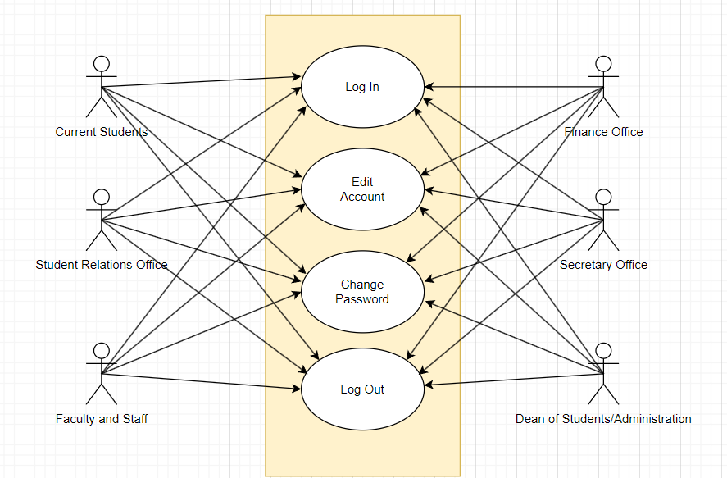

**Language Selection**

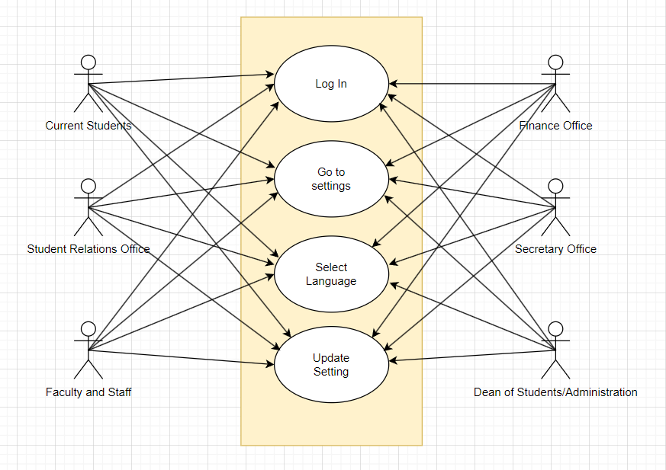

**New Student Application**

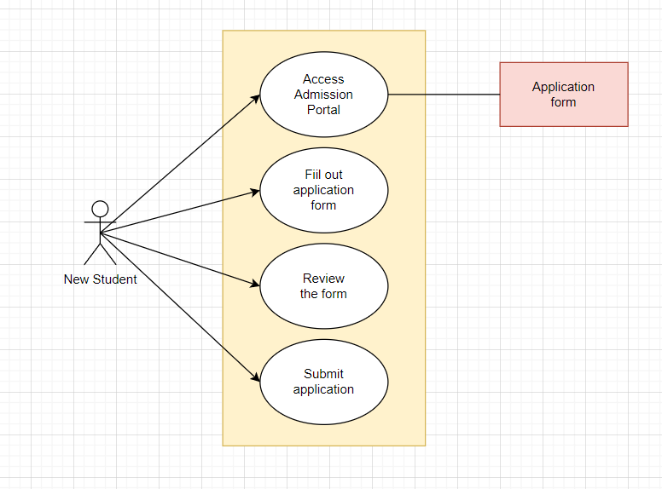

**SRO Views Pending List SRO Edits Pending List**

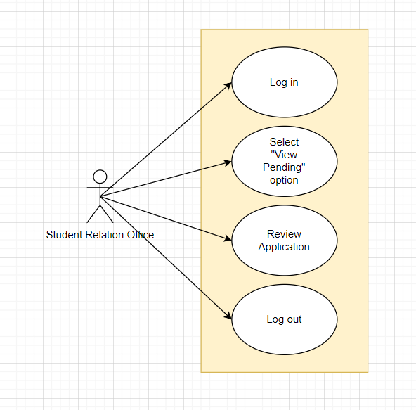 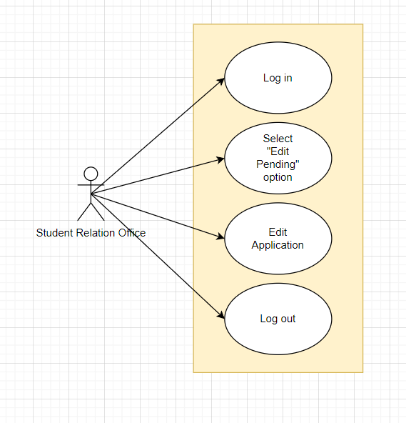

**SRO Views Transaction List SRO Views Registered List**

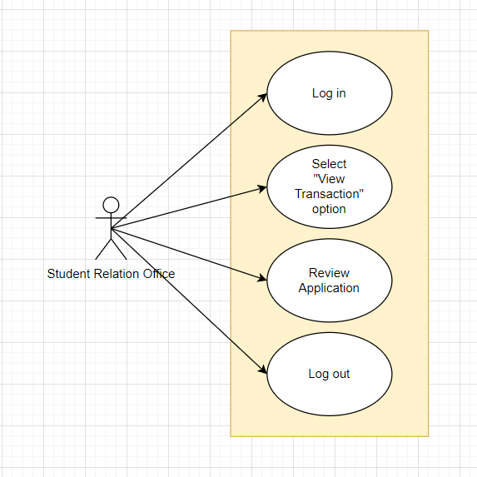 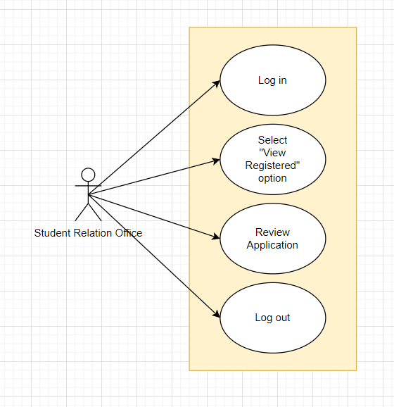

**FO Views Pending List FO Views Transaction List**

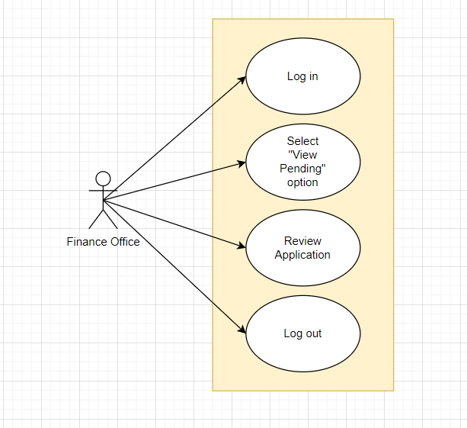 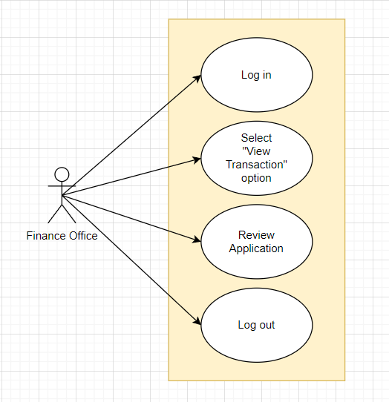

**FO Edits Transaction List FO Views Registered List**

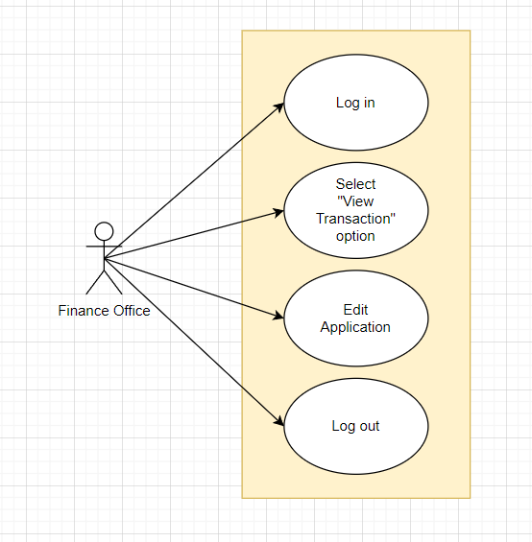 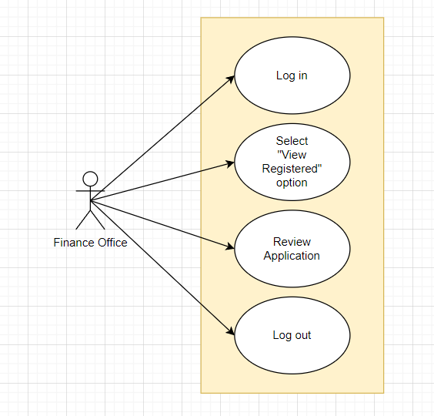

**SO Views Pending List SO Views Transaction List**

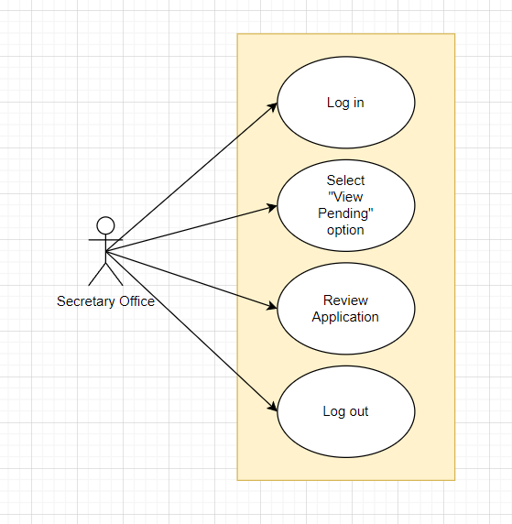 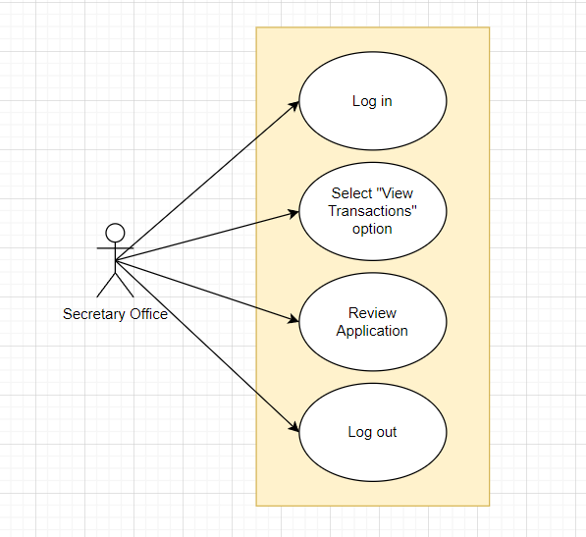

**SO Views Registered List SO Edits Registered List**

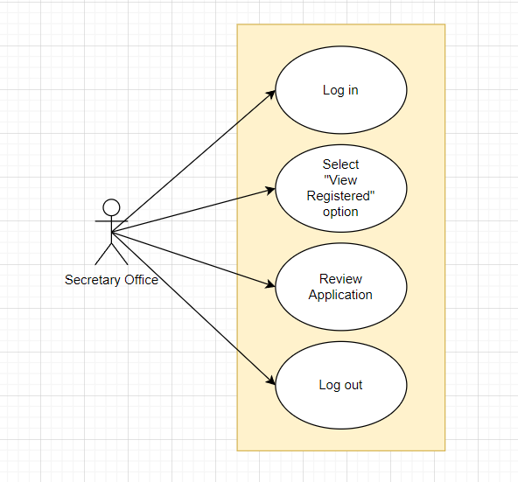 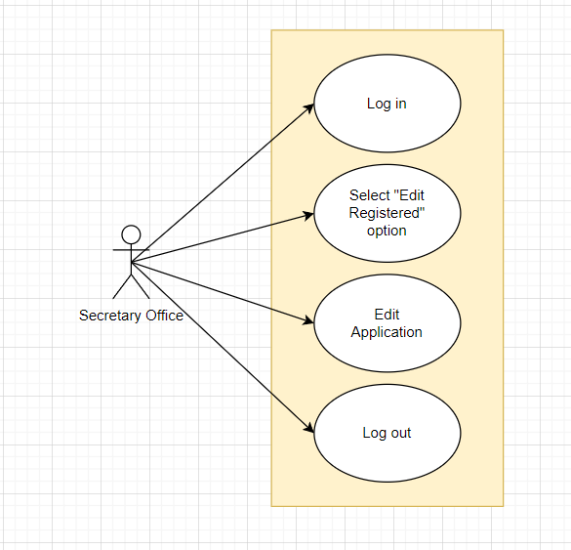

**Professors View Pending List Professors View Transaction List**

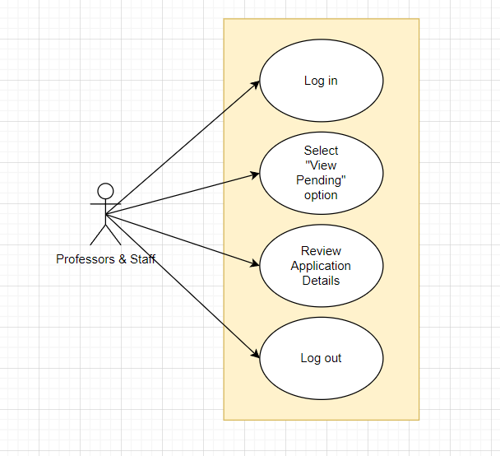 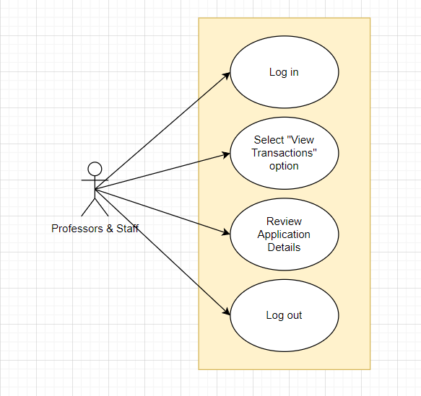

**Professors View Registered List Create Student Activity**

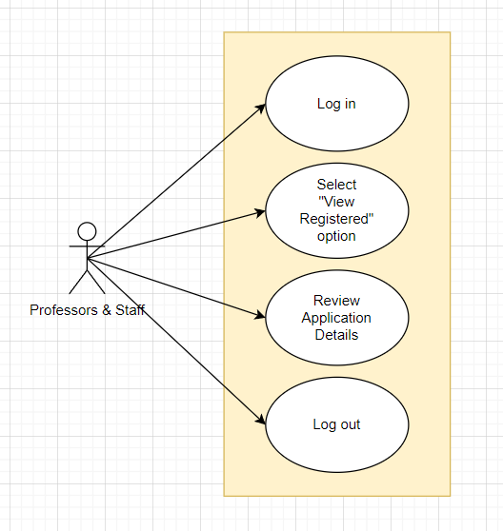 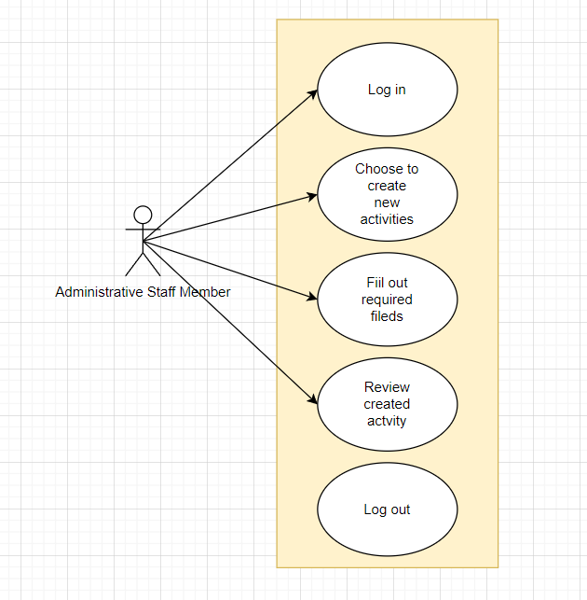

**Manage Student Activities Promote Student Activities**

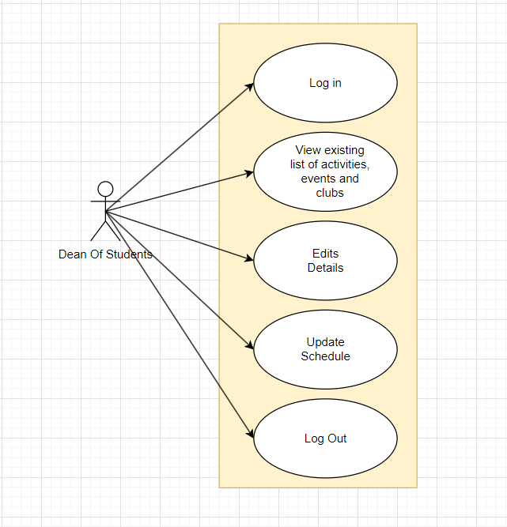 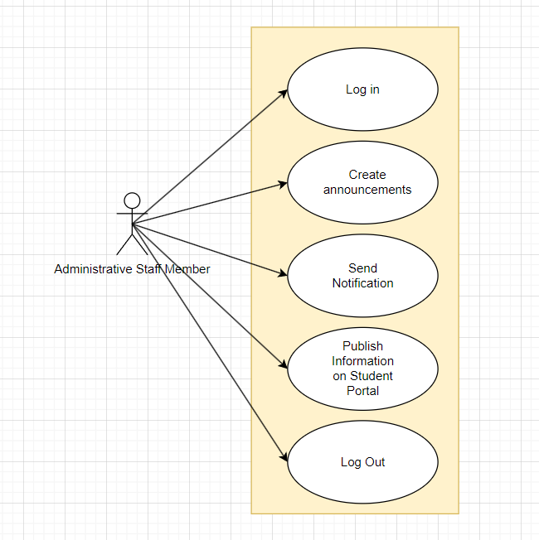

**Approve Student Requests Monitor Participation**

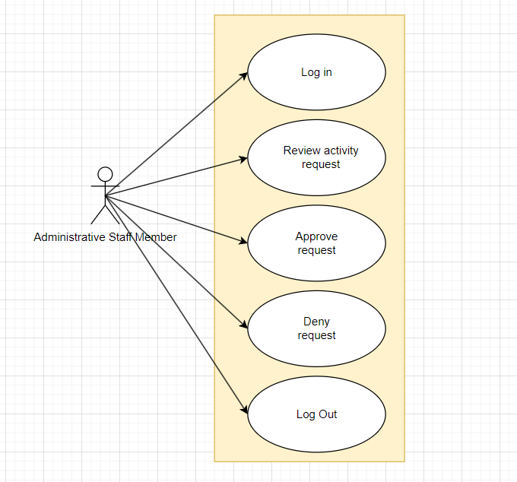 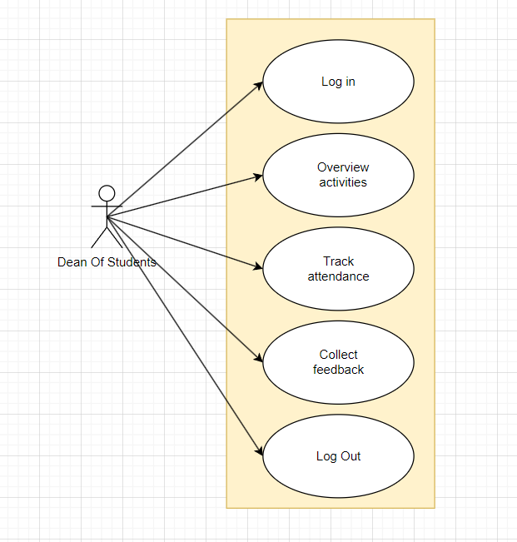

**Student Personal Information Student Portal Activities**

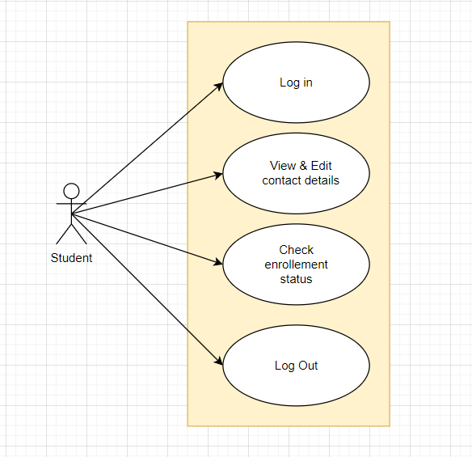 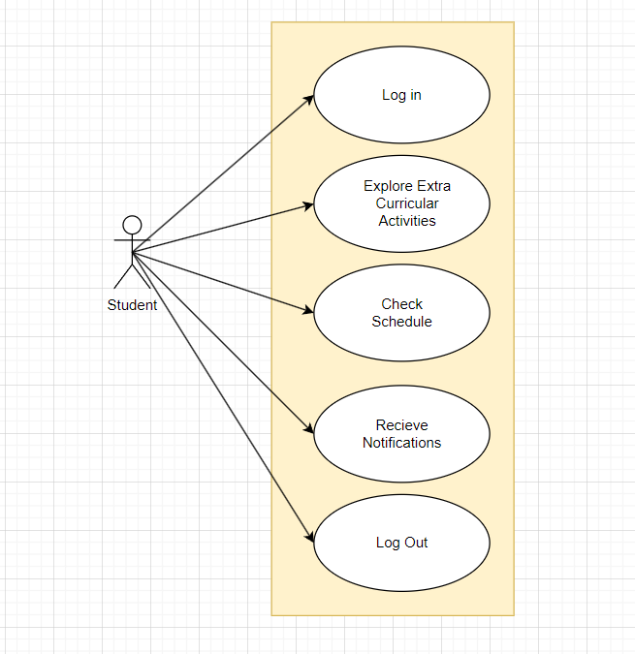

**4.4.2 Activity Diagrams**

**User Login Language Selection**

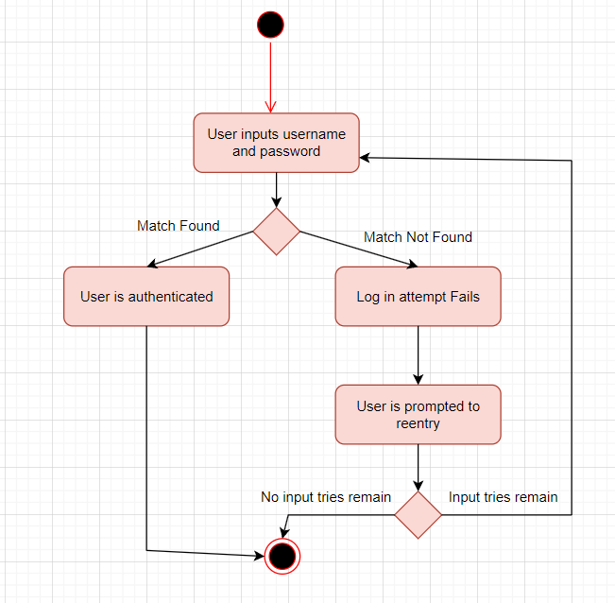 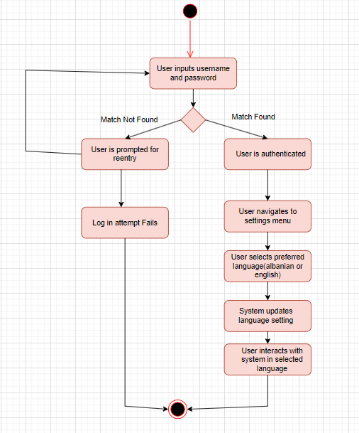

**New Student Application SRO Views Pending List**

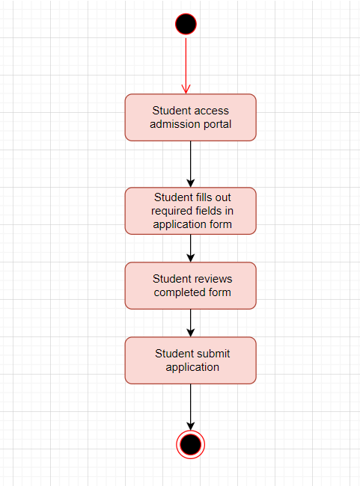 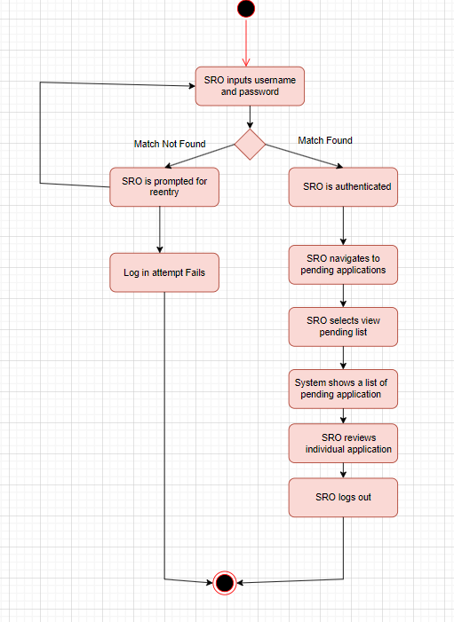

**SRO Edits Pending List SRO Views Transaction List**

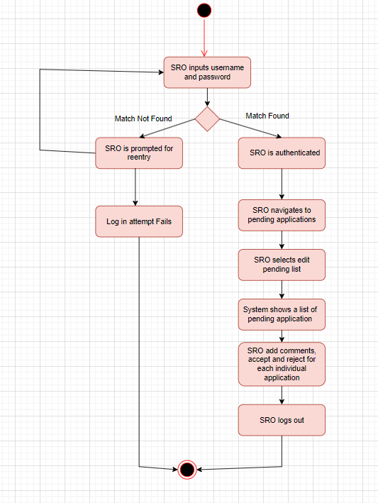 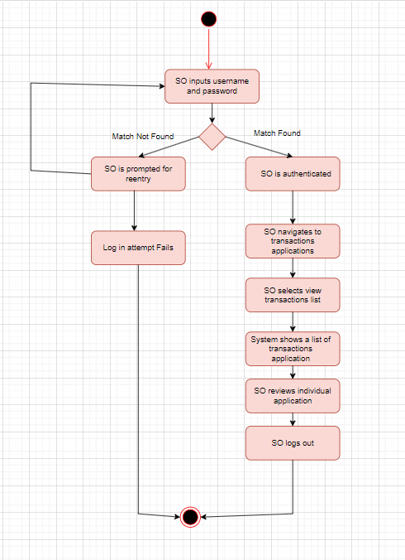

**SRO Views Registered List FO Views Pending List**

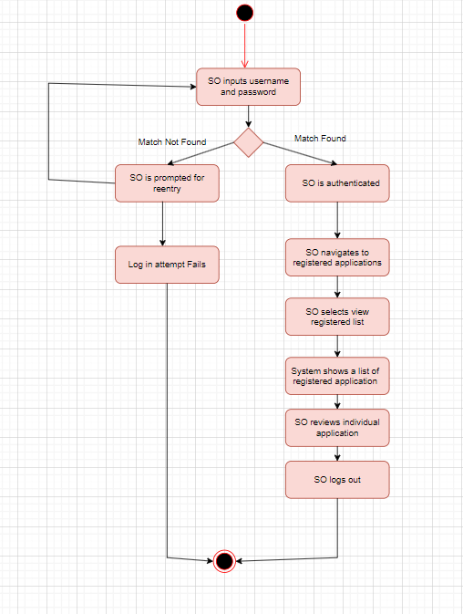 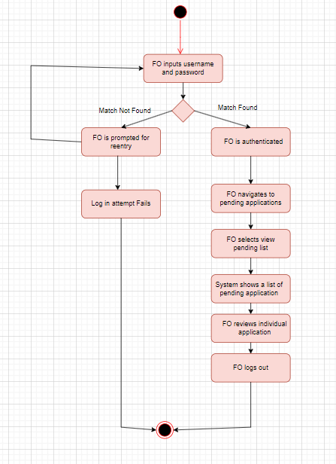

**FO Views Transaction List FO Edits Transaction List**

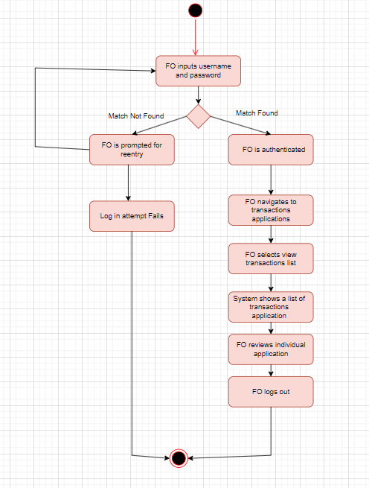 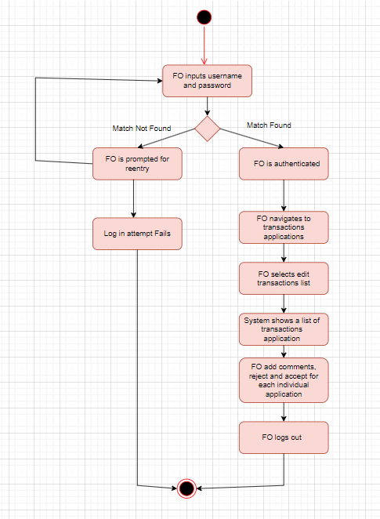

**FO Views Registered List SO Views Pending List**

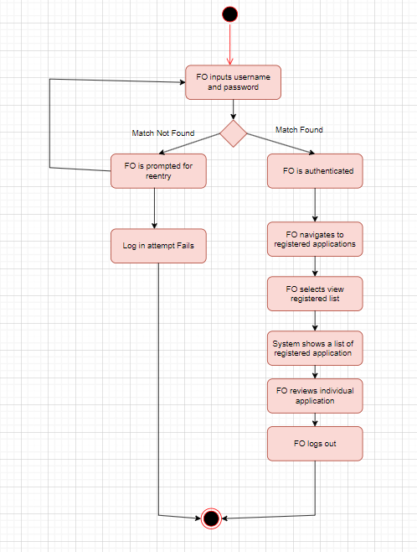 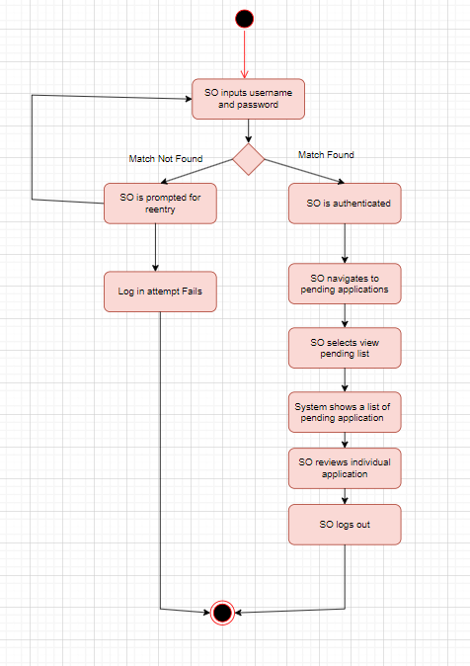

**SO Views Transaction List SO Views Registered List**

** **

**SO Edits Registration List Professors Views Pending List**

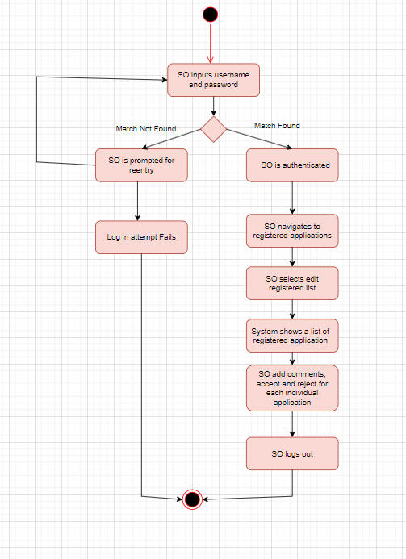 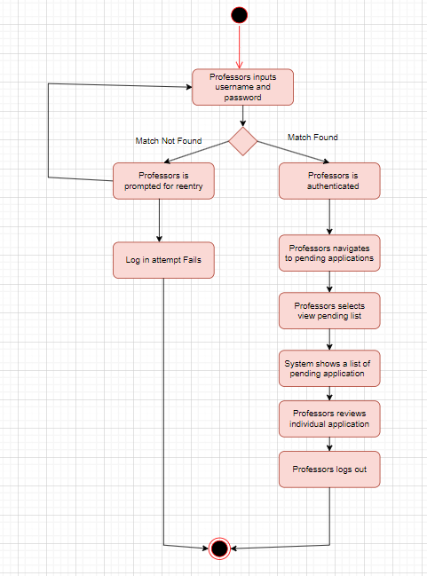

**Professors Views Transaction List Professors Views Registered List**

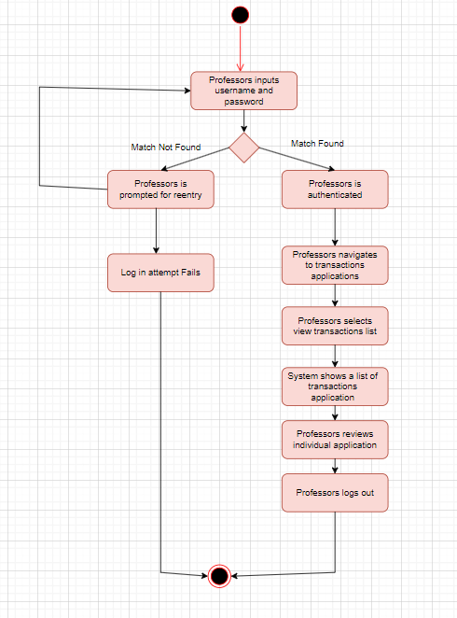 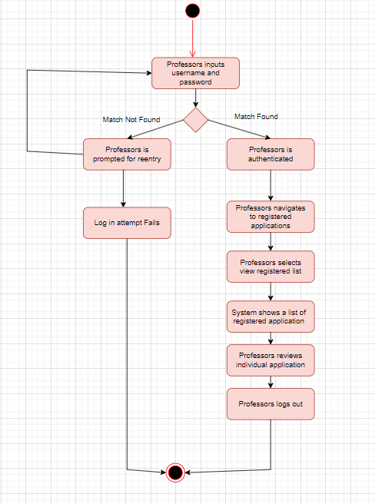

**Create Student Activities Manage Student Activities**

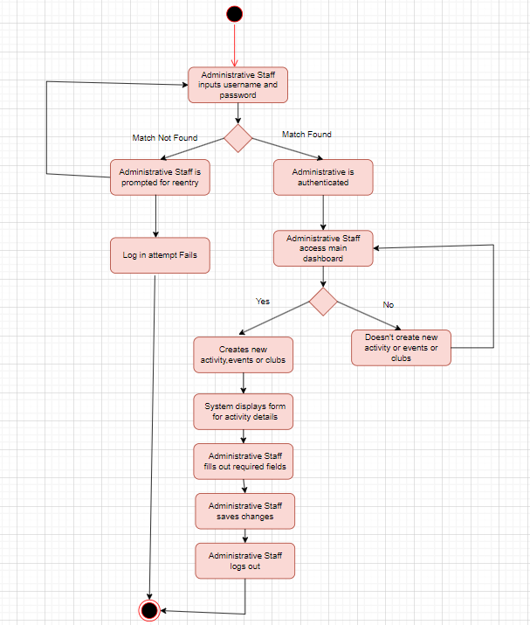 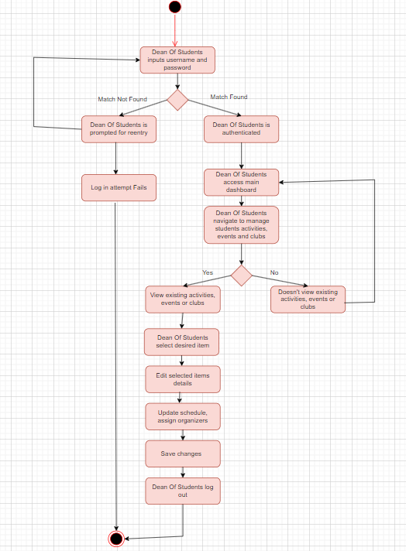

**Promote Student Activities Approve Student Requests**

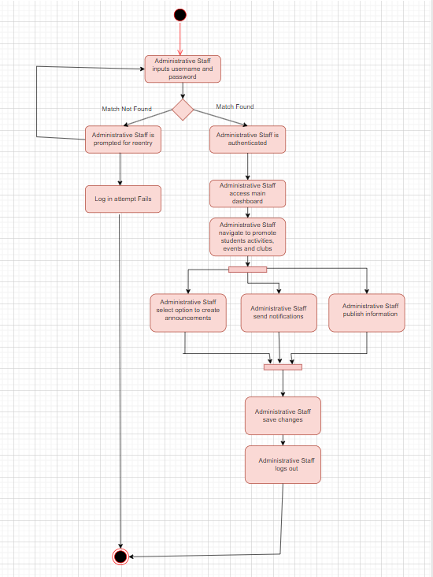 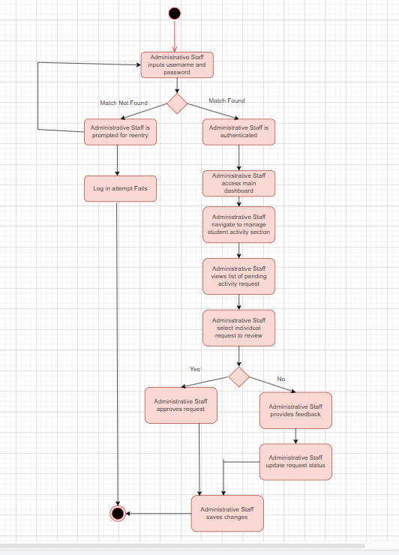

**Monitor Participation Student Personal Information**

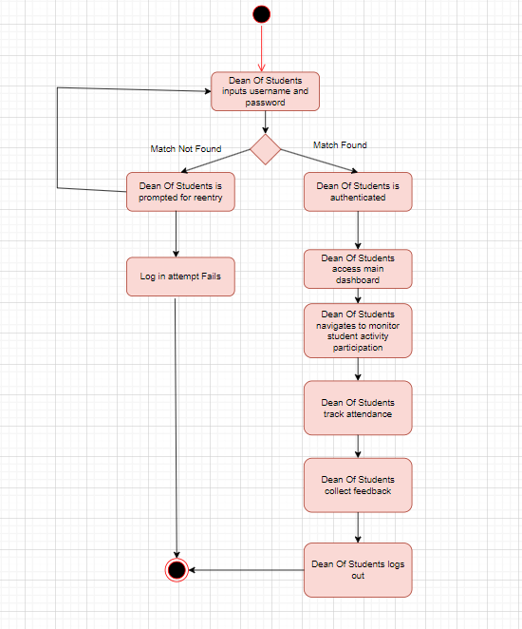 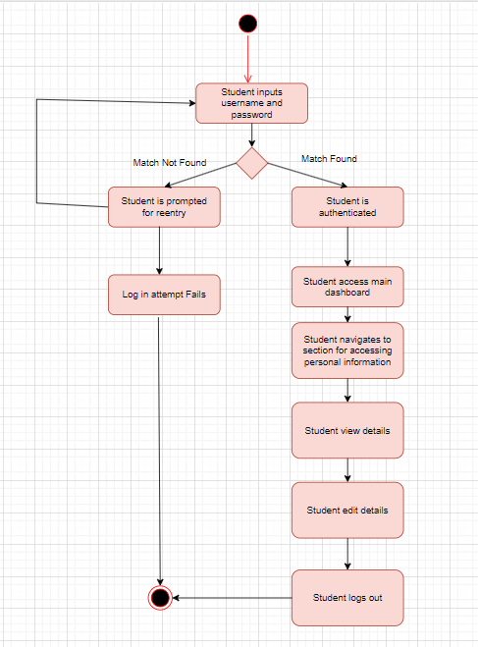

**Student Portal Activities**

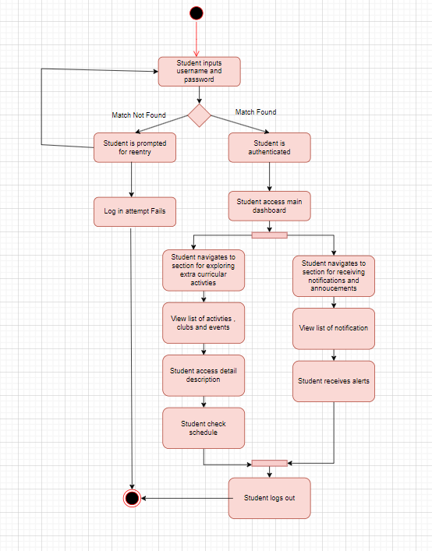

**4.4.3 State Diagrams**

**SRO STATE DIAGRAM**

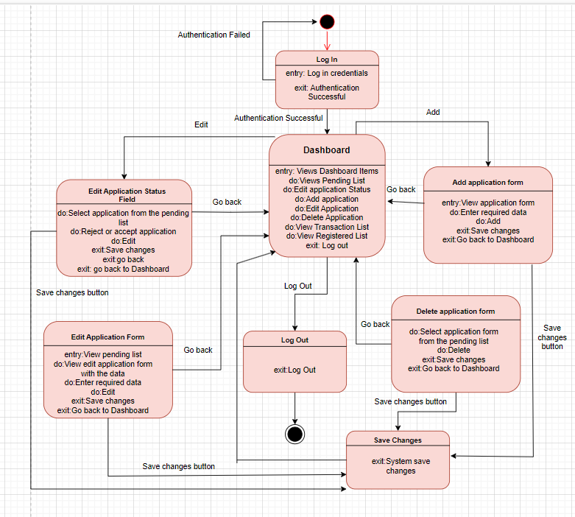

**SO STATE DIAGRAM**

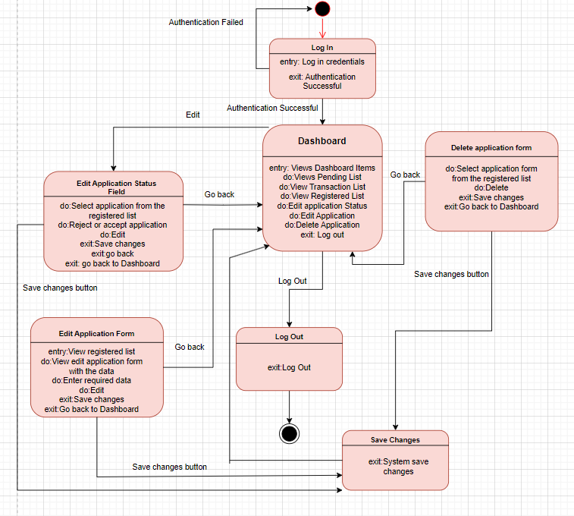

**FO STATE DIAGRAM**

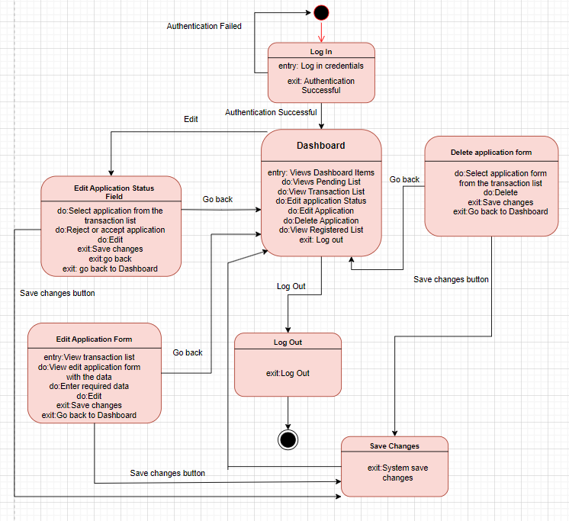

**Administrative State Diagram**

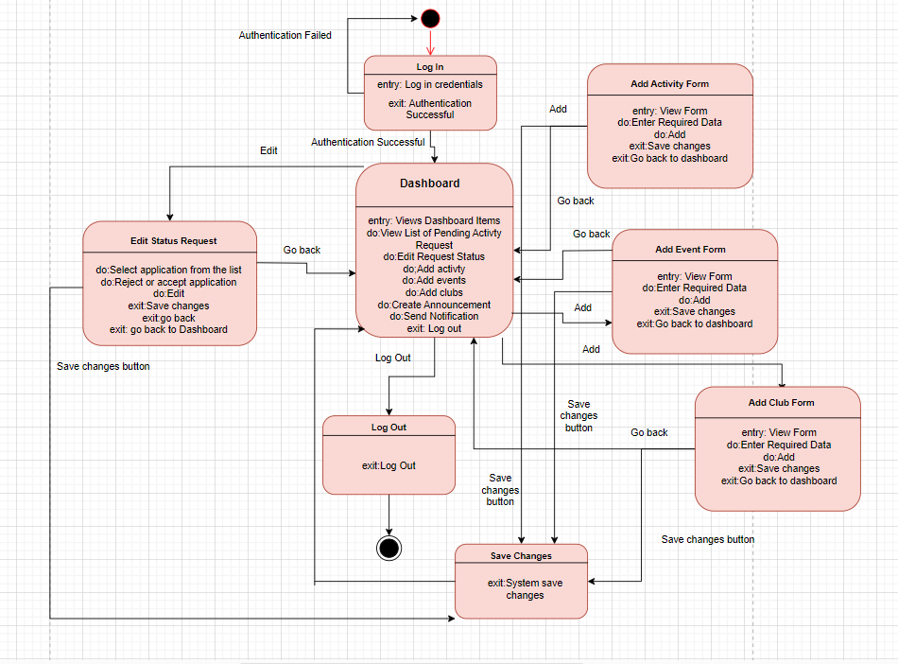

**Student Portal State Diagram**

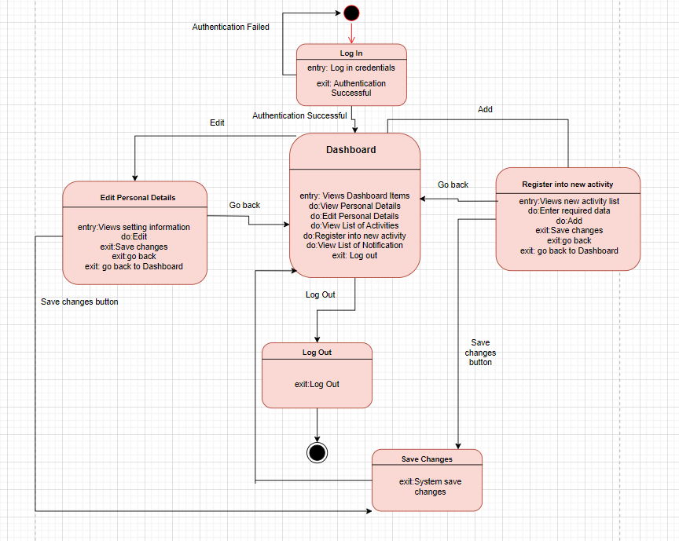

**4.5 Interaction Diagrams**

**4.5.1 Sequence Diagrams**

**Admissions Sequence Diagram**

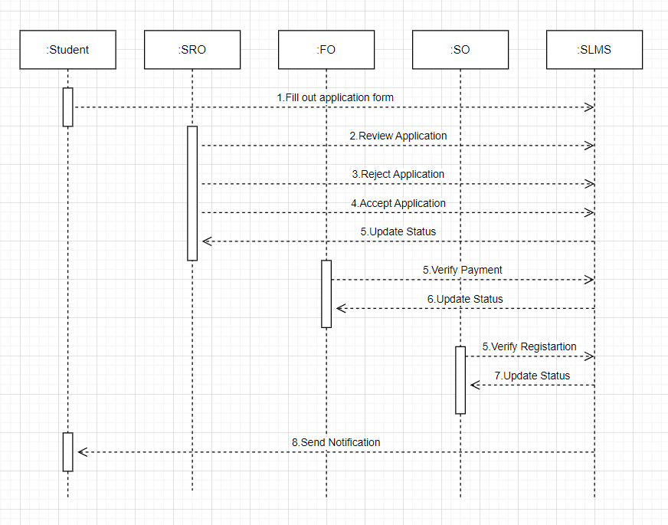

**Administrative Sequence Diagram Student Portal Sequence Diagram**

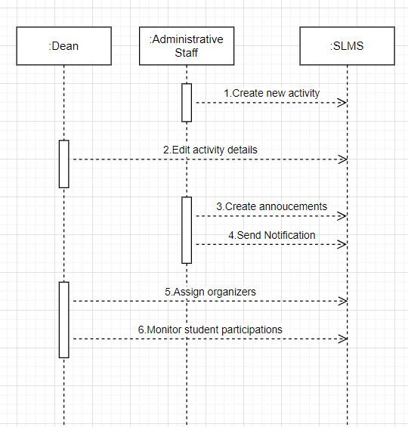 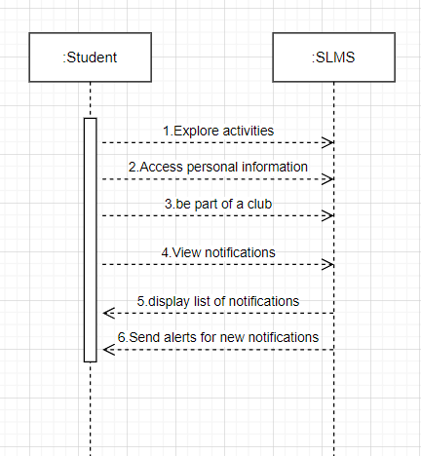

**4.5.2 Collaboration Diagram**

**Admission collaboration diagram Student Portal**

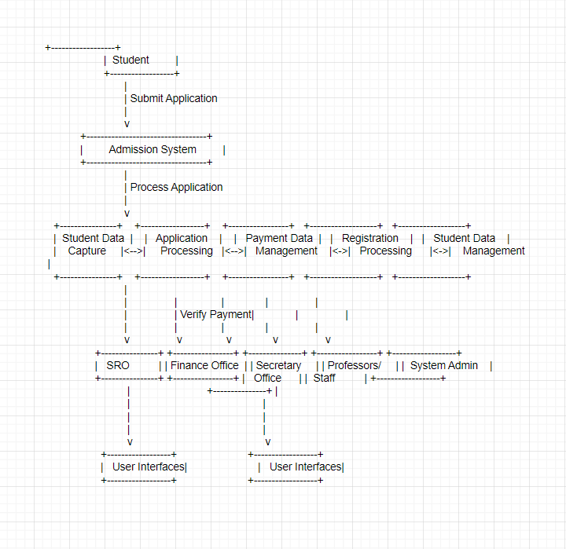 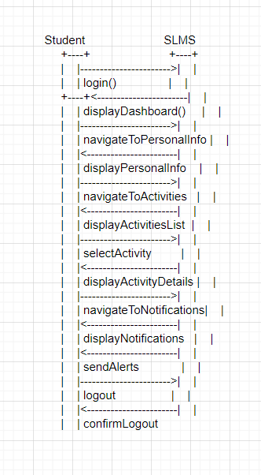

**4.6 Data Flow Diagram**

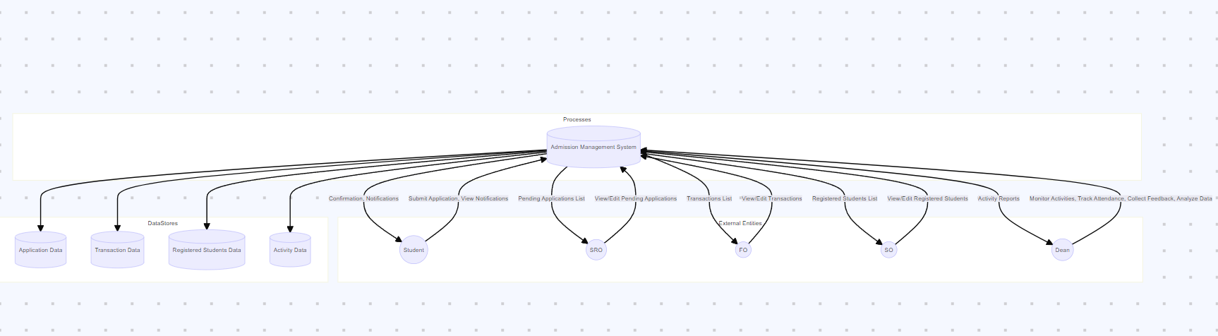

**4.7 BPMN**

**New Student applies to the university**

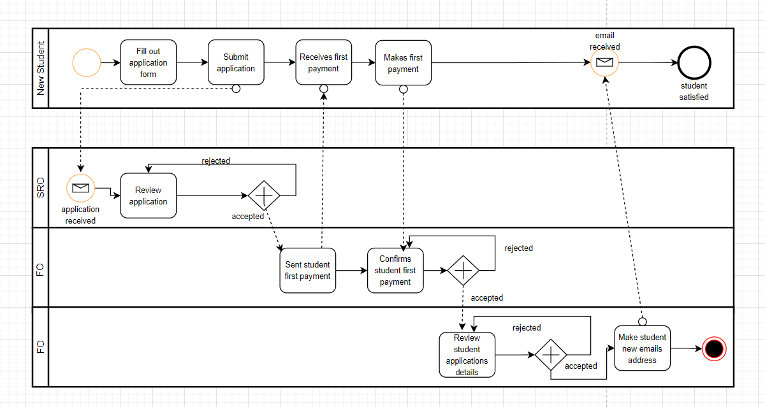

**Administrative and Portal System**

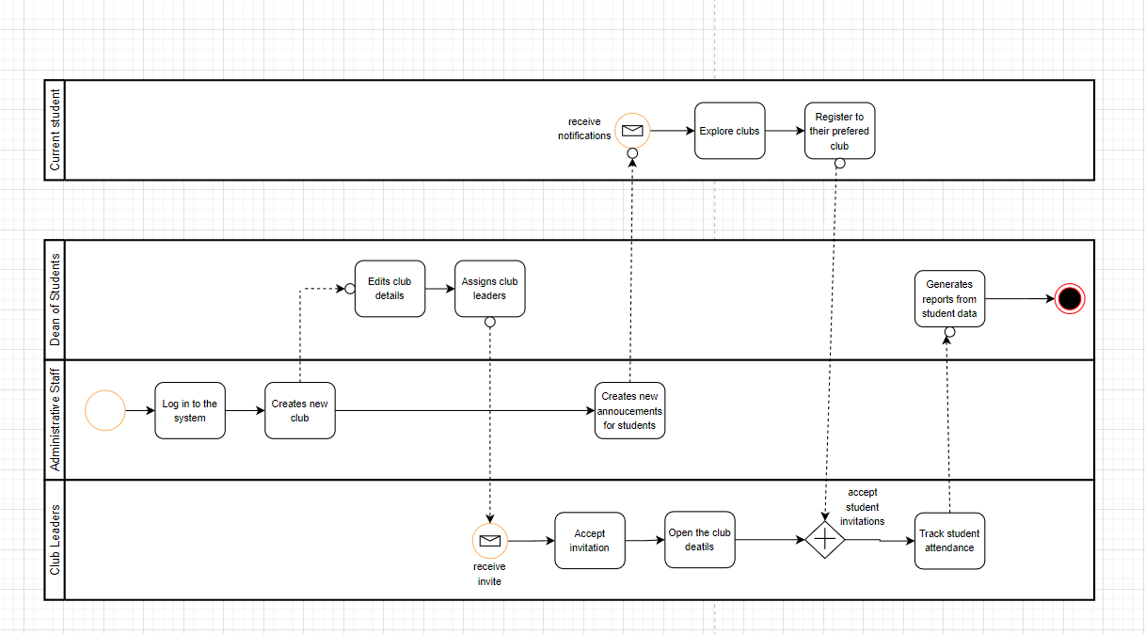

**4.8 Structural Diagrams**

**4.8.1 ERD Diagrams**

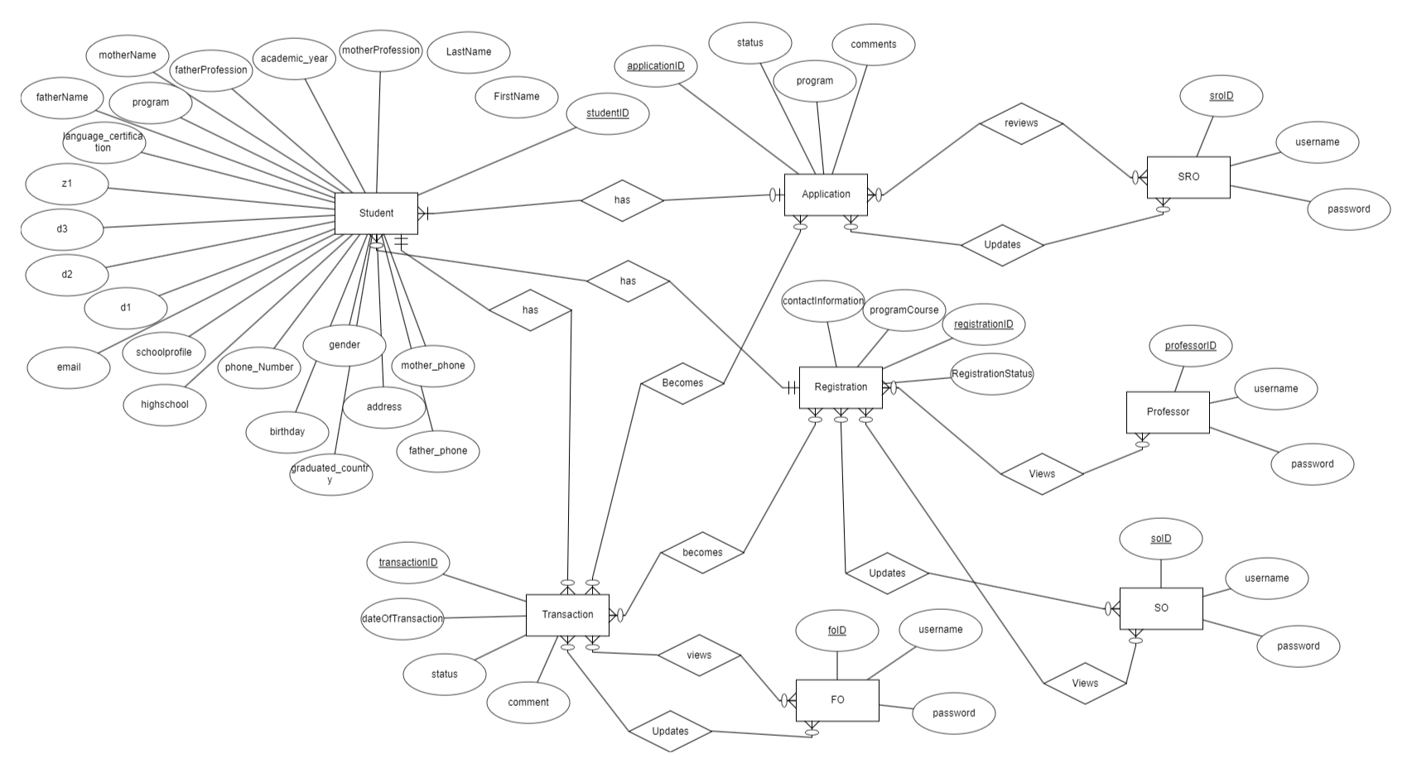**Admission System**

**Administartive System**

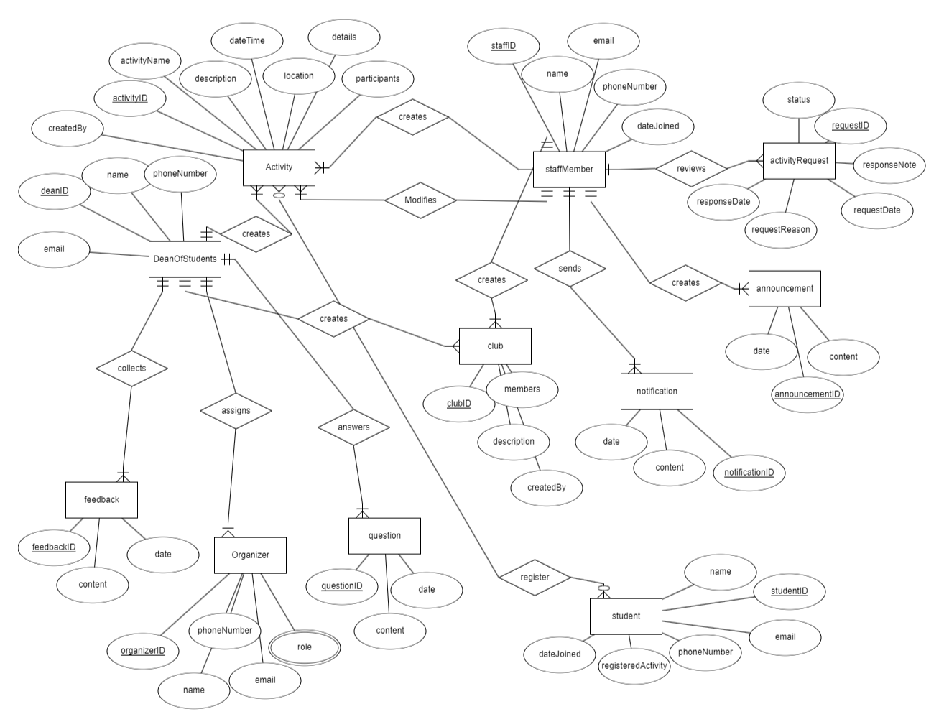

**4.8.2 Relationship Schema**

**Admission Relationship Schema**

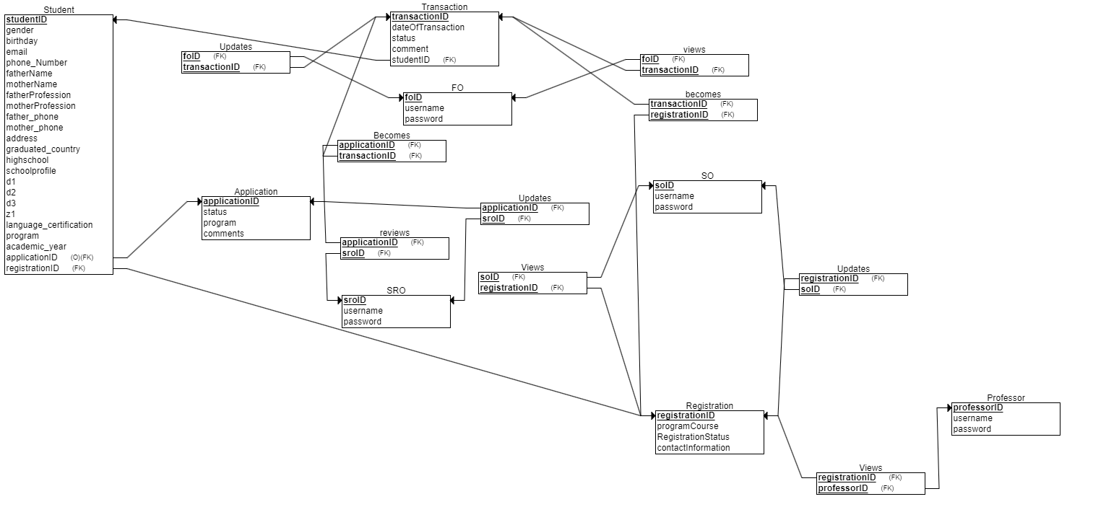

**Administrative Relationship Schema**

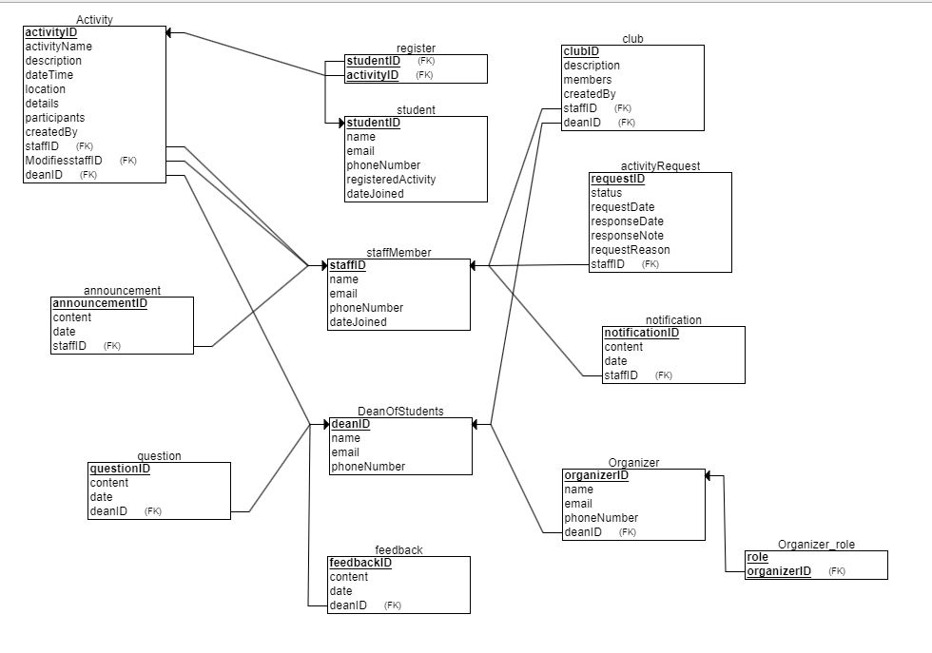

**4.8.3 Class Diagram**

**Admission System**

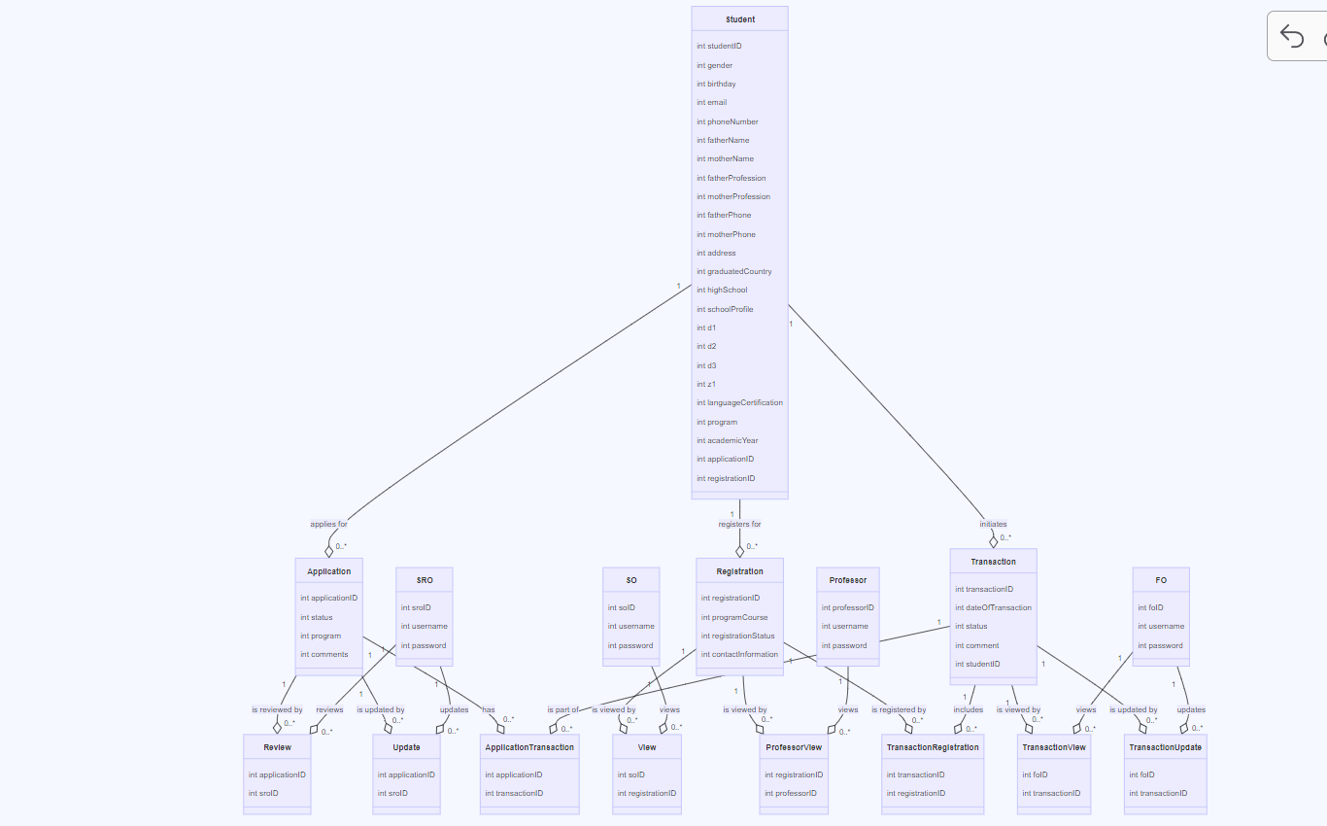

**Administrative System**

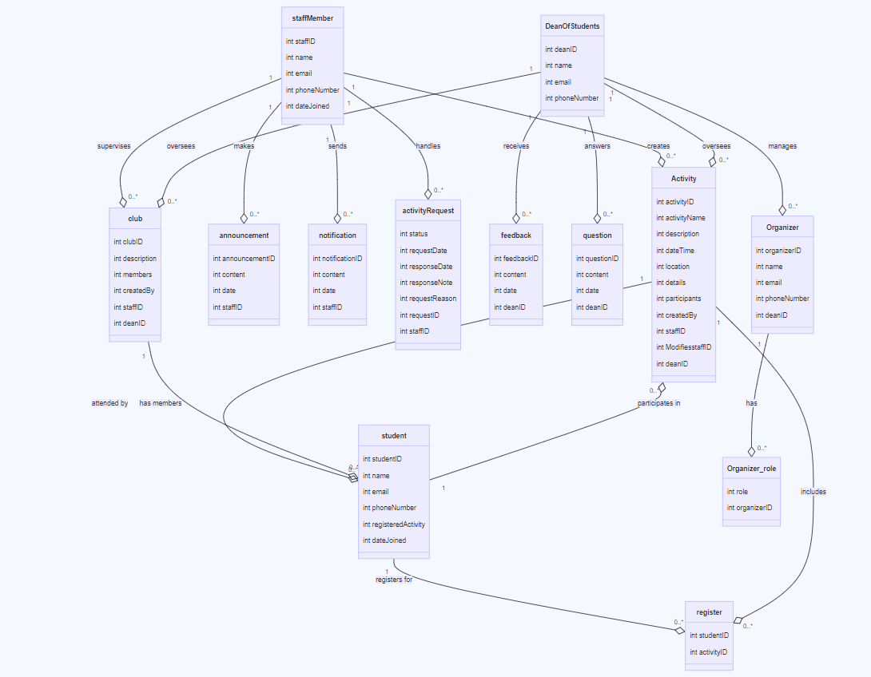

**5.Project Planning**

|  |  |
| --- | --- |
| **Team Member** | **Duty** |
| Joana | Talking with the client and taking the requirements from them  Doing the diagrams  Doing the sketches  Editing the documentation file |
| Xhorxhina | Talking with the client and taking the requirements from them  Building the front end functionalities(html,css,javascript)  Building the back-end funcionalities (php)  Doing the project power point presentation |
| Dea | Talking with the client and taking the requirements from them  Building the front end functionalities(html,css,javascript)  Building the back-end funcionalities (php) |

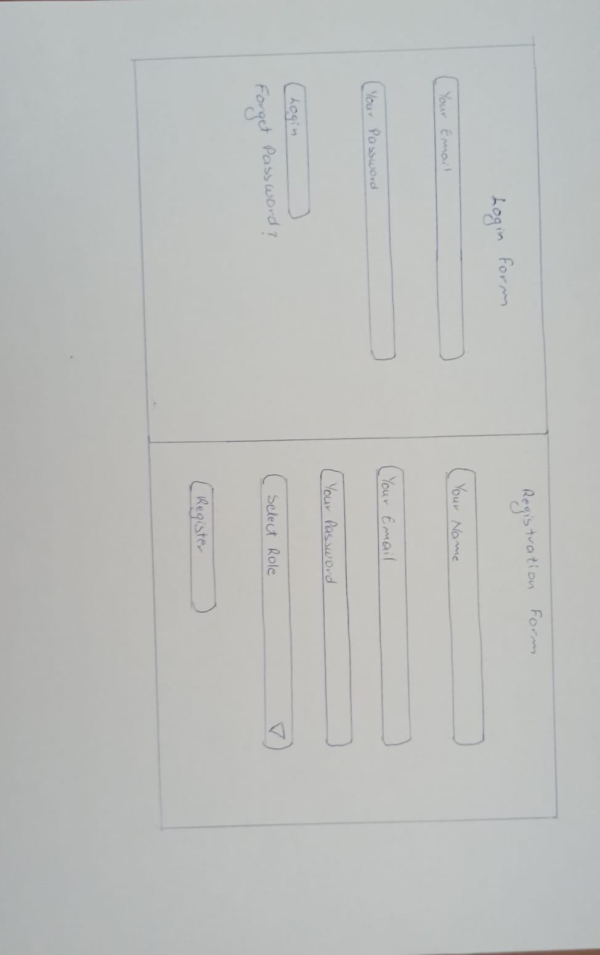

**Appendix A**

**Sketches**

**1 .LOG IN**

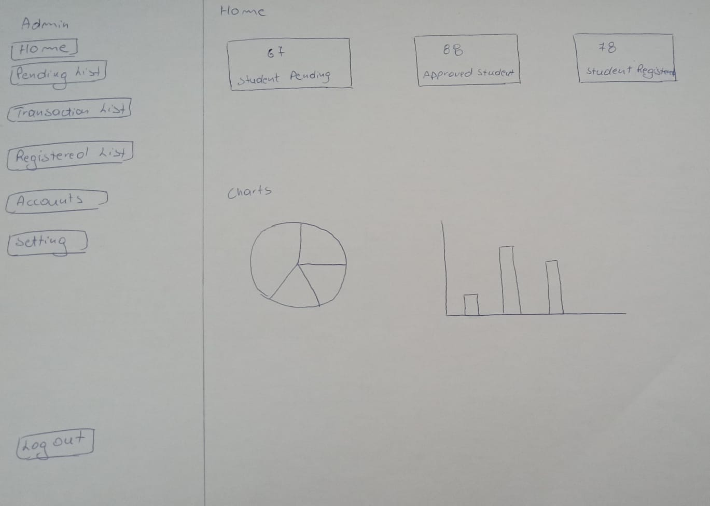**2.Admin Home**

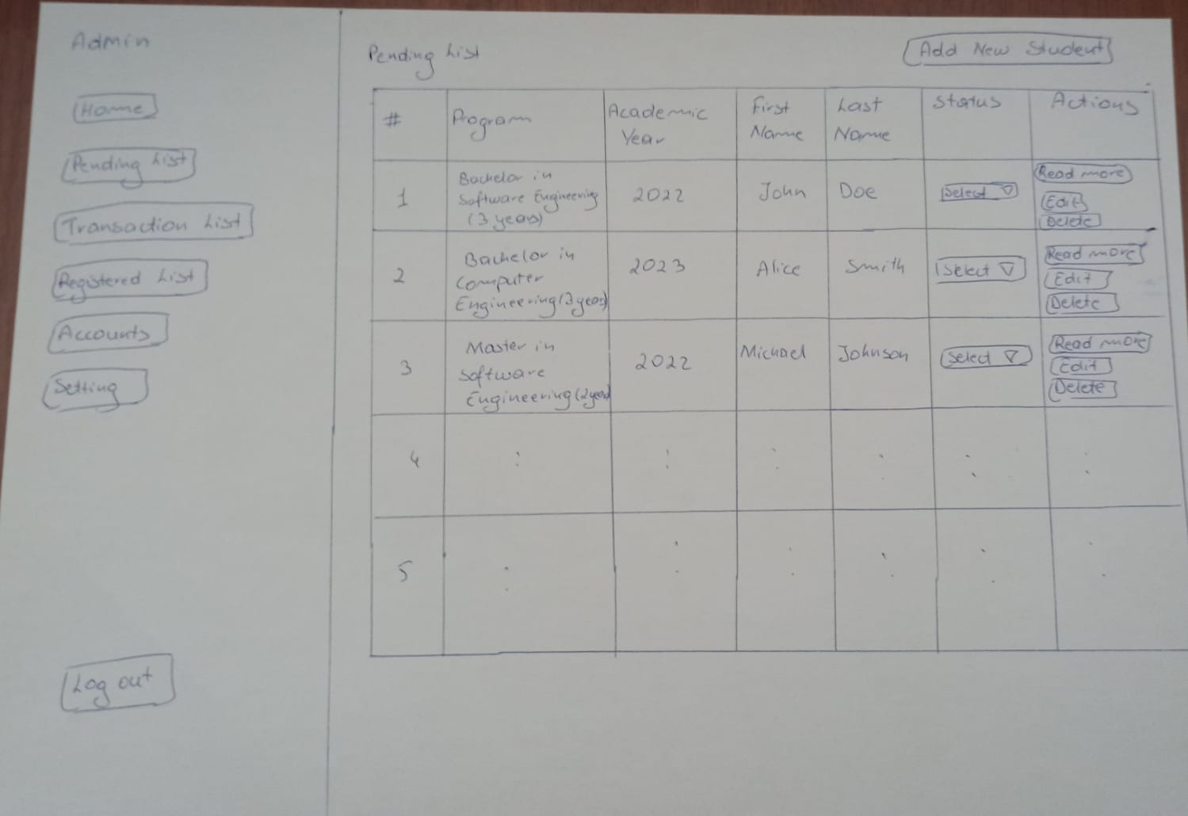**3.Admin Pending List**

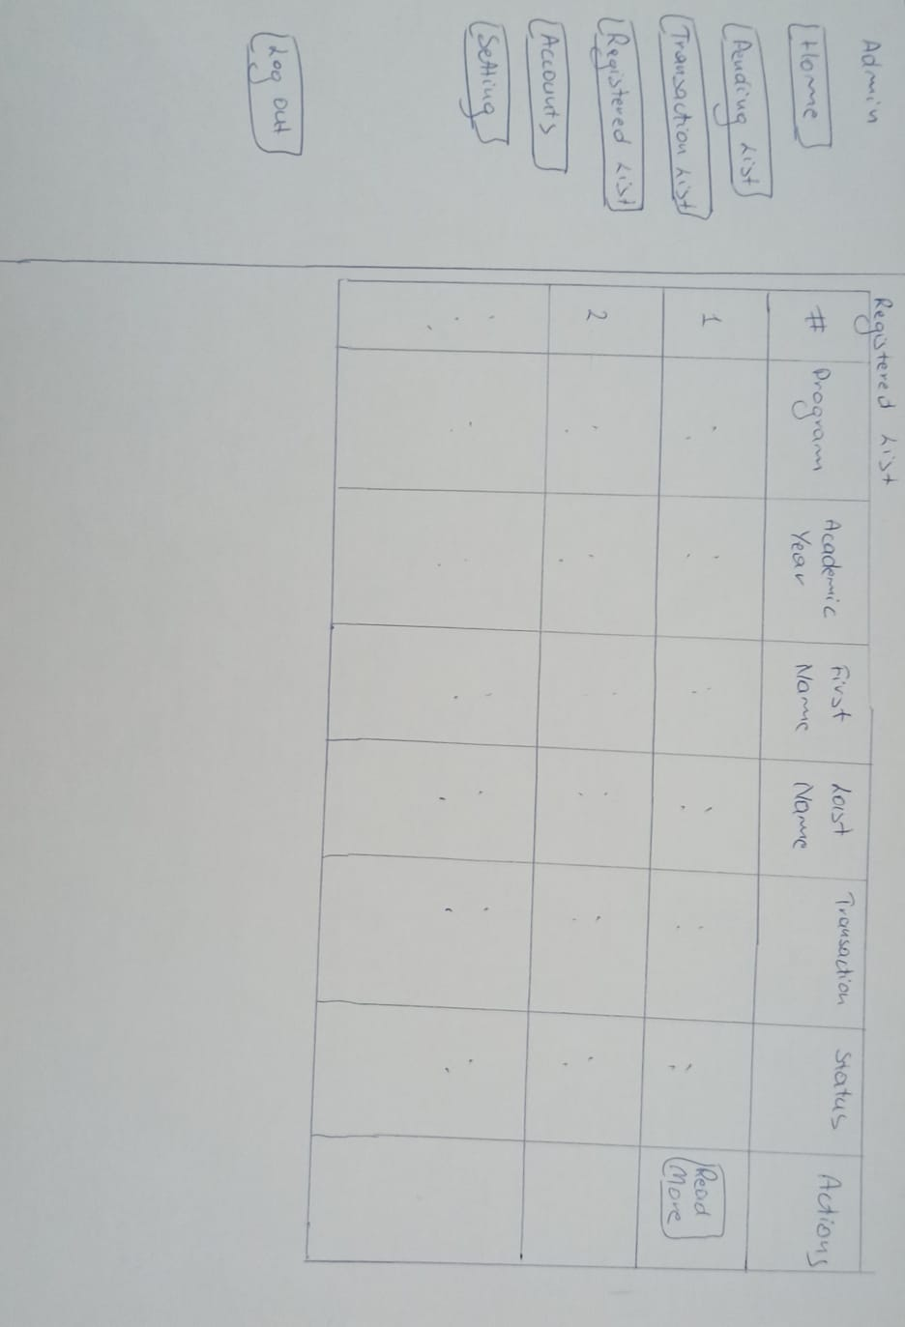**4.Admin Registered List**

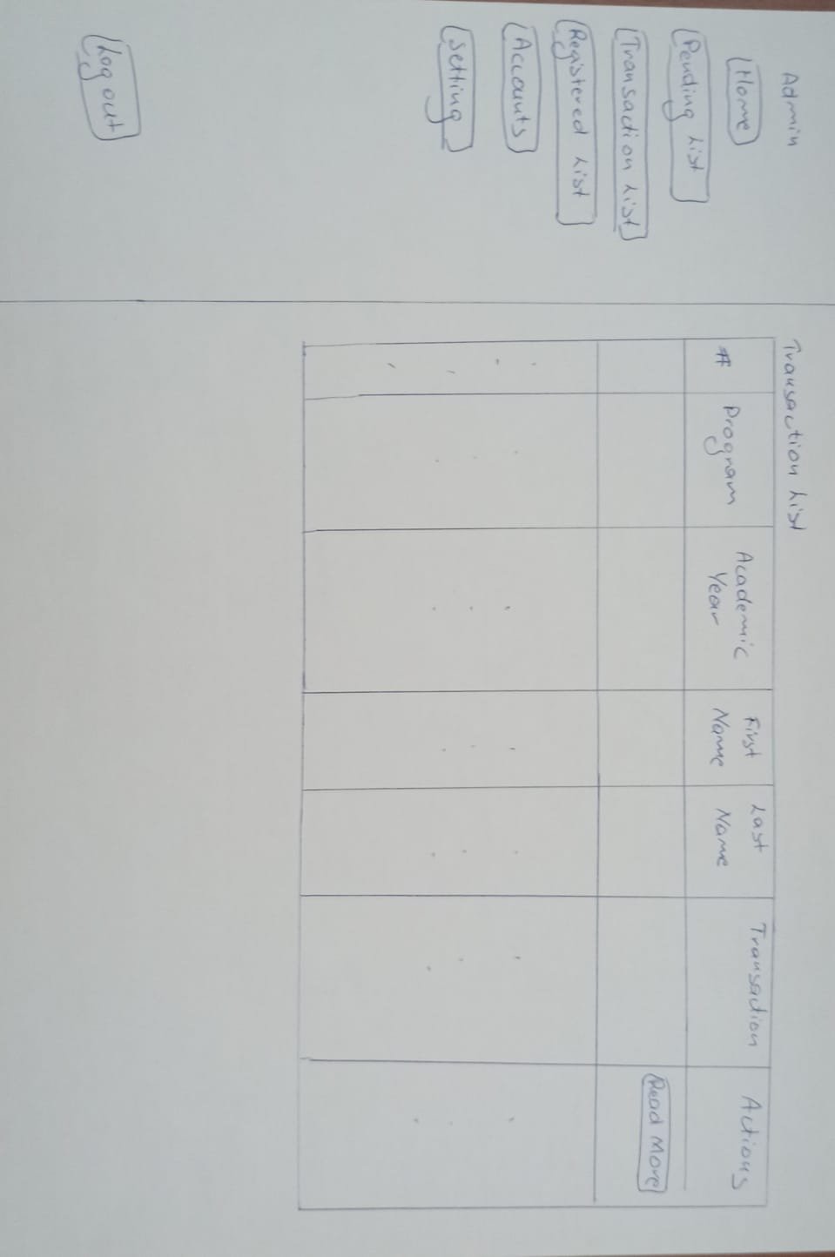**5.Admin Transaction List**

**6.Student Application Form**

